Ladies Golf Club of Marbella
FROM THE RED TEES

  HOME
  2013 LCOM BOARD
  FROM THE RED TEES
  PHOTO GALLERY
  2013 CALENDAR
  ABOUT LCOM
  FORMS
  PAST NEWSLETTERS
  ~CHAIRMAN~
  Chairman
  
  Bev Letter
  BEV LETTER
  SEPTEMBER NEWSLETTER
  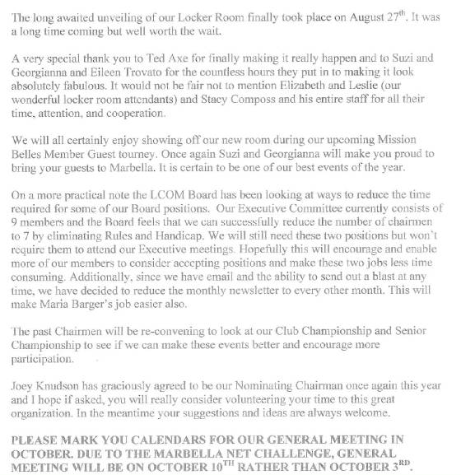
  ~ MEMBERSHIP ~
  Sherri Romito
  MEMBERSHIP
  
  SHERRI ROMITO
  Membership Sherri Romito
  The Ladies Club Roster consists of 92 regular members and 27 handicap only members.
  Birthdays for the month of September are:
  Micki Hayama September 13
  Joey Knudson September 20
  Patsy Dryer September 21
  Yolanda Talbot September 21
  Linda Danto September 24
  Dorothy Matsuba September 25
  The winner of the drawing for the discount in the pro shop is
  Joey Knudson
  WSCGA Tournaments
  Tournament information is posted in the locker room along with entry forms.
  The tournaments include:
  WSCGA Foundation Golf Fundraiser at Monarch Beach Golf Links on Thursday September 12
  Open Play Day on September 23 at Robinson Ranch Golf Club
  Masters Championship at Pala Mesa Resort on September 30 and October 1
  Proposed by-law amendments and the reason for the changes are in a memorandum posted in the locker room also.
  JOIN THE LADIES CLUB:
  CONTACT: Sherri Romito 949-248-2453 949-248-2453 FREE sromito@aol.com
  CLUB CHAMPIONSHIP
  AUGUST 8, 2013
  CLUB CHAMPION
  
  SUSAN TAYLOR
  RUNNER UP
  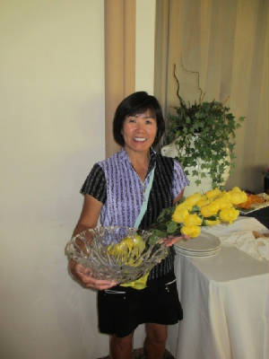
  KAREN JORDAN
  FIRST PLACE GROSS - PATTY COLLINS
  
  FIRST PLACE NET - LINDA TRAVIS
  FIRST PLACE GROSS
  
  CONNIE MERLIS
  FIRST PLACE NET
  
  BARBARA BEHRENS
  SECOND PLACE GROSS - JUNE KIM
  
  SECOND PLACE NET - PATTI STRINGER
  THIRD PLACE NET - KAY WOOD
  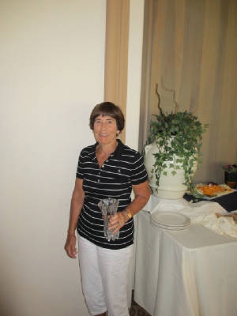
  FIRST PLACE GROSS - JEAN KELLY
  GENERAL MEETING
  SEPTEMBER 5, 2013
  FLIGHT A FIRST PLACE
  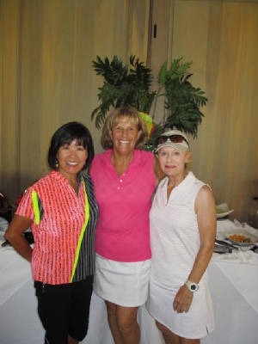
  KAREN JORDAN, JILL BLURTON-JONES, JEAN KELLY & CHERYL MARQUIS
  FLIGHT B FIRST PLACE
  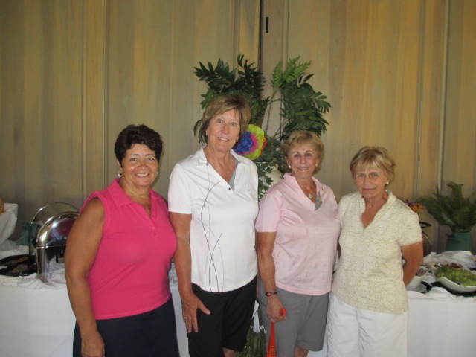
  eLENA MILLER, MARCIA SMITH,DIANE SIEGEL & CAROLYN MCGUIRE
  FLIGHT B SECOND PLACE
  
  NANCY CLEEREMANS,KAY WOOD, MIKI HAYAMA & HELEN HELBING
  ~ MAJOR TOURNAMENTS ~
  Yolanda Talbot
  MAJOR TOURNAMENTS
  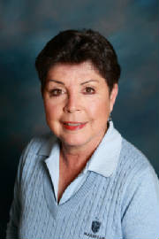
  YOLANDA TALBOT
  ~ PLAY DAYS ~
  Barbara Behrens
  PLAYDAY CHAIRPERSON
  
  Barbara Behrens
  Ladies...The Pro shop is doing a great job in helping with the Thursday Play Days. If
  you have any favorite games you like to play, please let me know.
  Thanks, Barbara
  ~GUEST DAYS ~
  Nancy Tall
  GUEST DAYS CHAIRMAN
  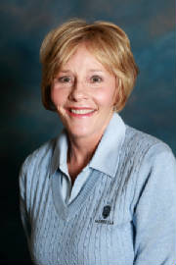
  NANCY TALL
  Hello ladies,
  Our next guest day will be November 14th.
  Look for details in future Newsletters!
  Nancy Tall
  ~ HANDICAP ~
  Connie Merlis
  HANDICAP
  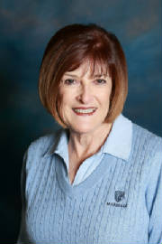
  CONNIE MERLIS
  August 1-31, 2013 MOST IMPROVED GOLFERS
   |  |  |  | Starting |  | Ending
   |  | Name |  | Index (Hdcp) |  | Index (Hdcp) |  | Factor
  1 |  | Sophie Bendush |  | 19.3 (22) |  | 17.7 (20) |  | 1.054
  2 |  | Sonya Mahony |  | 21.0 (24) |  | 19.5 (22) |  | 1.048
  3 |  | Christina Templeton |  | 11.7 (13) |  | 10.7 (12) |  | 1.044
  4 |  | Nancy Cleeremans |  | 19.2 (22) |  | 18.2 (21) |  | 1.033
  5 |  | Lori Bickel |  | 25.0 (29) |  | 24.1 (28) |  | 1.025
  ( ) = Handicap converted from red tees.
  HOLE-IN-ONE CONGRATULATIONS
  KATHY LYONS, AUGUST 7, HOLE 7
  ~ RULES CHAIRMAN ~
  Pattie Stringer
  PATTI STRINGER
  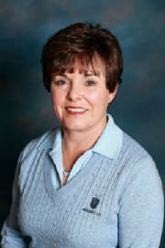
  RULES CHAIRMAN
  HOW MUCH DO YOU KNOW?-Rules Quiz
  1. In stroke play competition, the player must put an identification
  mark on his ball; if he fails to do so, he incurs a two stroke penalty.
  True or False
  2. In stroke play, a player returns his score card with a total score
  that is correct but with a score missing for one hole.
  a. The committee should allow him to enter he missing score.
  b. The committee should enter the missing score.
  c. He is disqualified.
  3. In stroke play, a player incorrectly substitutes a ball when
  dropping after taking relief from casual water. What is the ruling if
  he has not yet played a stroke with the dropped ball?
  a. He must mark and lift the substituted ball and replace the
  original ball.
  b. He must lift the substituted ball and drop the original ball.
  c. There is a two stroke penalty and the substituted ball is the
  ball in play.
  Answers
  1. False, Rule 6-5 - It is highly recommended but not required.
  2. He is disqualified, Decision 6-6d/1
  3. He must lift the substituted ball and drop the original ball, Rule
  20-6
  PHOTOS
  Be sure to look at all our pictures
  on our Costco website.
  The login account is: marbellalc@yahoo.com
  The password is: 4marbella
  
  PHOTOGRAPHER
  ~ PK Jenican ~
  Please see our Photo Gallery at Costcophotocenter.com
  e-mail: marbellalc@yahoo.com password: 4marbella. If you have any photos from any of the events, we can still upload onto the website. Please let us know.
  If you order pictures to be picked up from Costco, use Mary Kay's name for the account!
  Anyone desiring a copy of a photo, please contact me with a description of the photo and I will gladly E-Mail you a copy. PK Jenican: P.k@camoves.com
  Past 2010/2013 Newsletters
  Thank you for visiting our web site!

