Ladies Golf Club of Marbella
FROM THE RED TEES

  HOME
  2013 LCOM BOARD
  FROM THE RED TEES
  PHOTO GALLERY
  2013 CALENDAR
  ABOUT LCOM
  FORMS
  PAST NEWSLETTERS
  ~CHAIRMAN~
  Chairman
  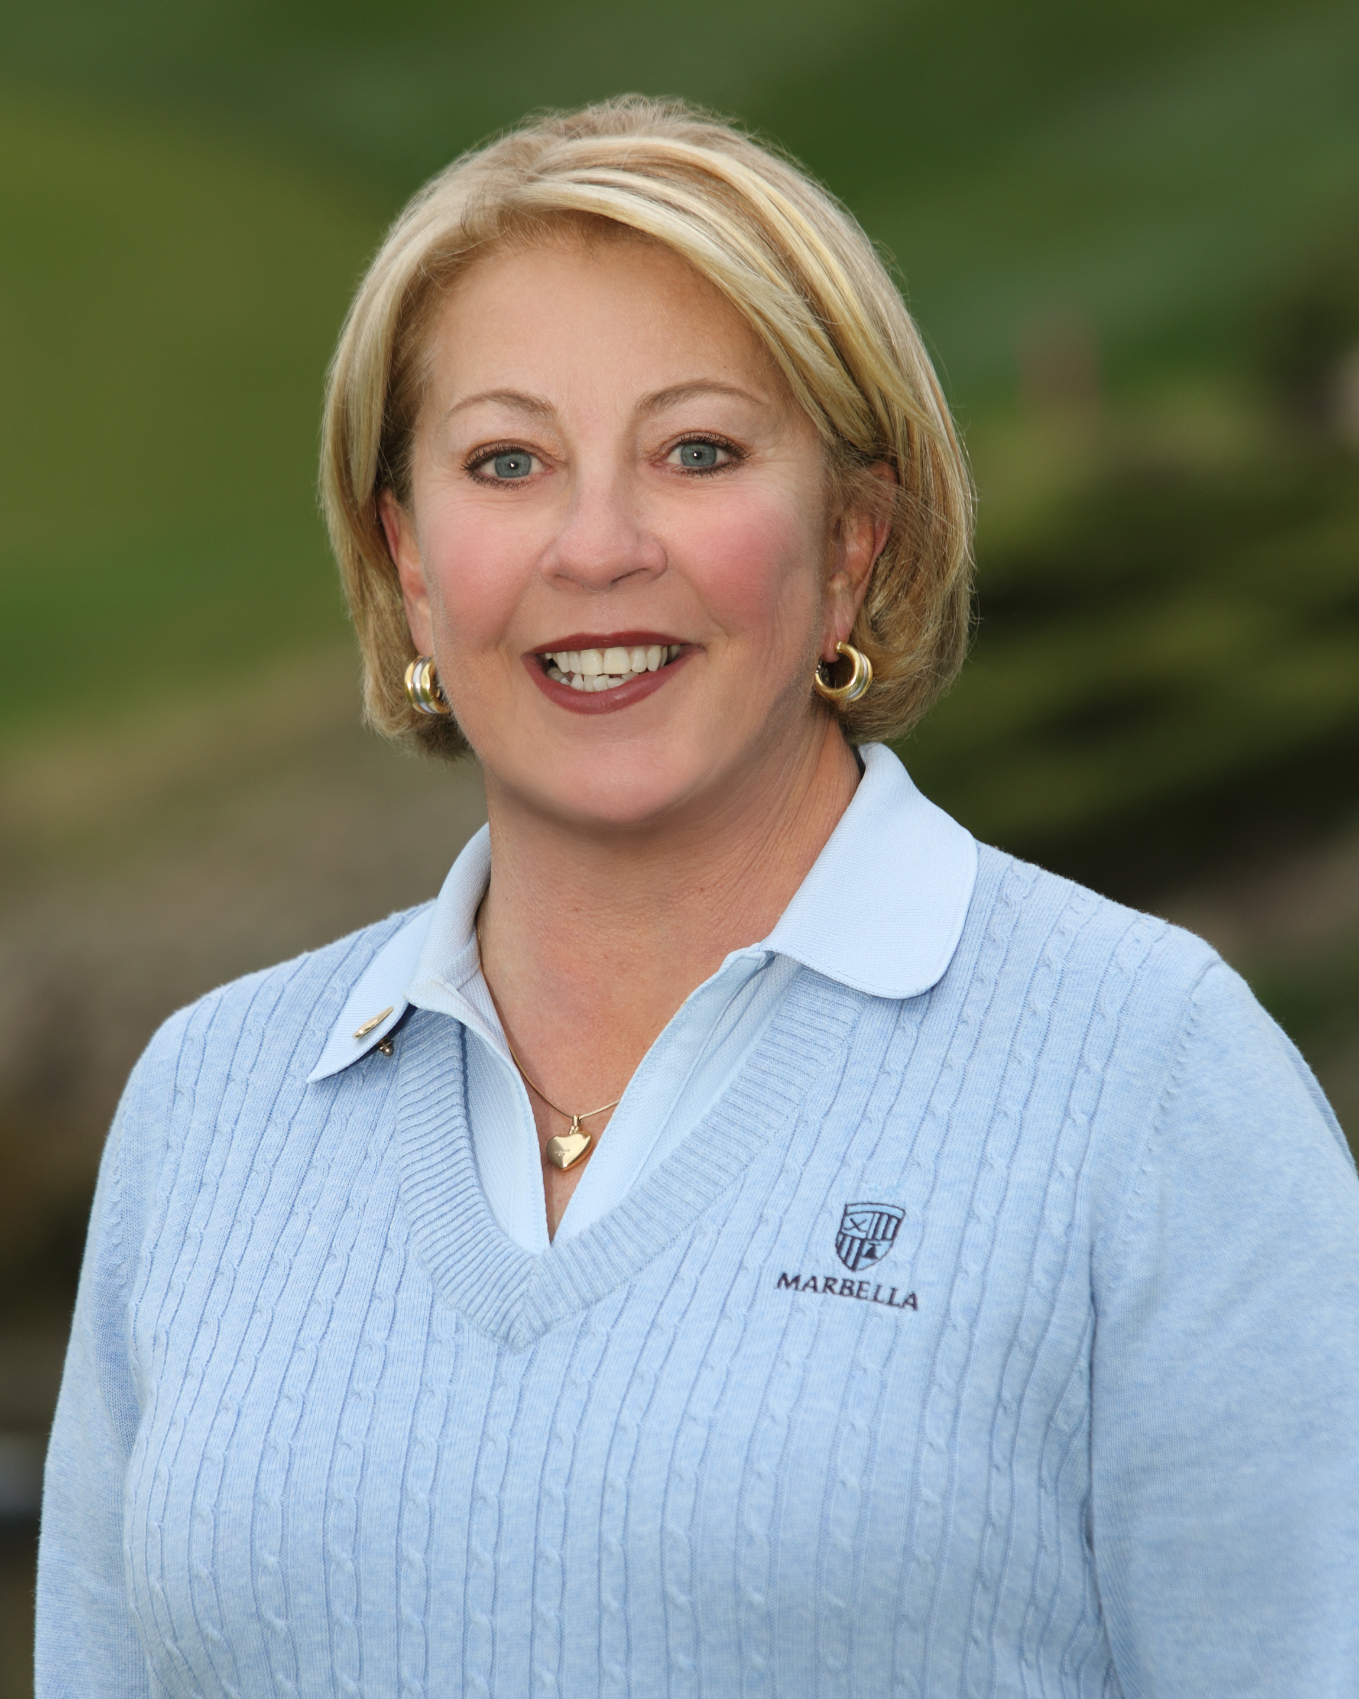
  Bev Letter
  BEV LETTER
  TWO DAYS TO REMEMBER
  The Ladies’ Club just celebrated their biggest event of the year with our two day Mission Belles Member Guest Event. With 100 participants it was one of our largest events ever.
  On the first day, we were serenated by the San Juan Ballet de Folklorico as we shopped for bargain deals at the Mercado and enjoyed homemade pastries followed up with street tacos on hand made to order tortillas. Then it was off to play some golf on our course, which is in absolutely beautiful shape. Everyone totally enjoyed stopping at Joe’s Bar on hole number 4 for some libation and laughter. Joe’s electrifying personality and warm smile made it hard to go to the next hole.
  After enjoying our time on the course, we met for cocktails and appetizers on the terrace and were entertained by Spanish dancers beautifully dressed in their traditional Mexican attire. Dinner was then served to us in the dining room, which had been totally decorated to compliment our Spanish theme. No one left without commenting on how delicious our lobster and steak entrées were and how beautiful the setting was.
  The second day was just more of the same and included several wonderful items to be offered in a raffle. The grand prize being a diamond necklace valued at $2400.00.
  All in all it was THE BEST EVENT EVER!!!
  Our guests left with nothing but wonderful comments and our members were so very proud of Marbella.
  A very BIG BIG thank you to Georgianna Hales and Suzi Olsen, their committee, and the entire Marbella staff. It has certainly made an impression on all of us and is certain to be the talk of the town at our neighboring clubs.
  Another big thank you goes to Joey Knudson, our Nominating Chairman, and her committee for slating our Officers for the 2014 Ladies’ Club Board. The vote of acceptance will occur at our next General Meeting and we will be off to another great year.
  Thank you all for all of your support. The Ladies’ Club would not exist without you!!
  Bev Letter
  Chairman
  SEPTEMBER NEWSLETTER
  ~ MEMBERSHIP ~
  Sherri Romito
  MEMBERSHIP
  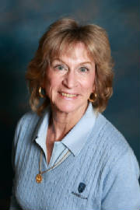
  SHERRI ROMITO
  Membership Sherri Romito
  The Ladies Club Roster consists of 92 regular members and 27 handicap only members.
  Birthdays for the month of October are:
  Marjorie Warren October 1
  Rebecca Pflueger October 15
  Nancy Clark October 21
  Toni Taylor October 21
  Heidi Bae October 24
  Nancy St. Pierre October 24
  Diane Siegel October 28
  Chick Pernell October 29
  The winner of the drawing for the discount in the pro shop is.
  Toni Taylor
  WSCGA Tournaments
  Tournament information is posted in the locker room along with entry forms.
  The tournaments include:
  Net Championship at Sunset Hills (Thousand Oaks) on October 21.
  Tournament of Champions at Big Canyon (Newport Beach) on November 4.
  JOIN THE LADIES CLUB:
  CONTACT: Sherri Romito 949-248-2453 949-248-2453 FREE sromito@aol.com
  MISSION BELLES
  2013
  Congratulations!
  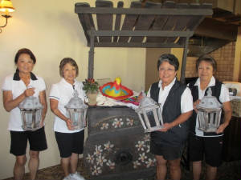
  Having Fun!
  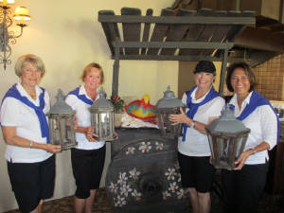
  What a great day!
  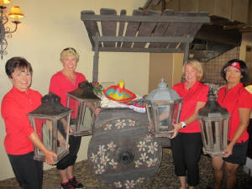
  Best day ever!
  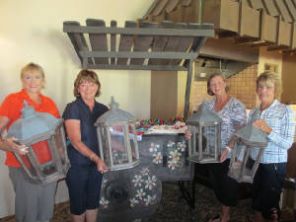
  To view all the pictures from the fabulous Mission Belles 2013, log into our costco site.
  http://www.costcophotocenter.com/album
  Login account # is Marbellalc@yahoo.com
  Password is: 4marbella
  Remember, if you order prints, please give Mary Kay Minner's name when you pick them up!
  GENERAL MEETING
  OCTOBER 10, 2010
  Overall Winner - TINA RUSSELL
  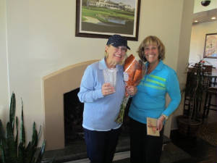
  First Place - JILL BLURTON-JONES
  Second, Third and Fourth Place
  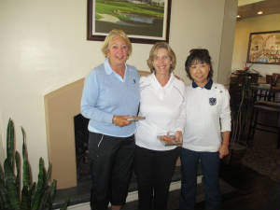
  BEV LETTER, LISA SHAW & MIKI HAYAMA
  MORE WINNERS
  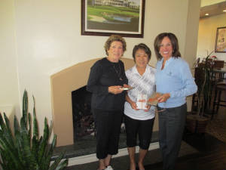
  CELIA FRANCESE, DOT MATSUBA & BARBARA BEHRENS
  A GOOD SPORT
  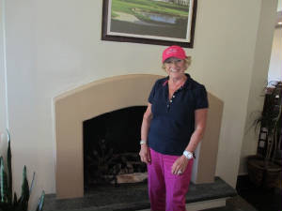
  TONI TAYLOR
  Marbella Net Challenge
  Last week LCOM held their first 2 day Net Tournament. Over 30 ladies competed for the coveted title of
  “Net Challenge Champion”.
  The 1st day’s competition was low net, and the 2nd day was Stableford scoring deducted from the first day’s Net. After two days of exciting, hard fought competition Tina Russell emerged as the Marbella Net Challenge Champion.
  Jill Blurton-Jones & Lisa Shaw ran the competition and I wish to thank the Pro staff and Catering staff for all their help and support.
  At the General Meeting Chef Robert served a fabulous lunch of Almond Crusted Sole with Risotto, accompanied by Apple Pie Martinis and Pumpkin Pie for desert……it was truly delicious!
  Congratulations to all the winners, and especially to Tina Russell who was awarded a beautiful engraved crystal vase.
  Marbella Net Challenge Winner Tina Russell
  Runner Up (card off) Jill Blurton-Jones
  2nd place Beverly Letter
  3rd place Lisa Shaw
  4th place Miki Hayama
  5th place Celia Francese
  6th place Barbara Behrens
  7th place Dorothy Matsuba
  8th place (card off) Ginny Vincent
  9th place Linda Travis
  ~ MAJOR TOURNAMENTS ~
  Yolanda Talbot
  MAJOR TOURNAMENTS
  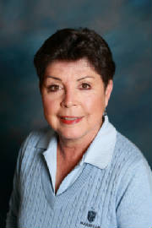
  YOLANDA TALBOT
  ~ PLAY DAYS ~
  Barbara Behrens
  PLAYDAY CHAIRPERSON
  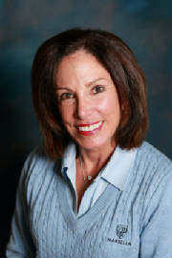
  Barbara Behrens
  Greetings Ladies...I know the Pro Shop is trying very hard to make our Play Day game cards correct. Please be patient with us and everything will be fine. However,
  please remember to hand in ONLY your game card to the pro shop and take in
  your POSTING card for posting and put it in the drawer for Connie. Your cards are
  designated posting or game. Thank You...Barbara
  ~GUEST DAYS ~
  Nancy Tall
  GUEST DAYS CHAIRMAN
  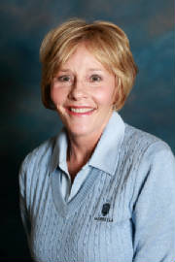
  NANCY TALL
  GIVING, GATHERING, GENEROSITY - HAPPY HOLIDAYS
  GUEST DAY NOV. 14th
  Sign up on Fore Tees. One to three guests.
  $45.00 includes continental breakfast, lunch, golf and prizes.
  Two best balls of foursome - Gross and Net
  Closest to Pin prizes - Longest drive prize
  Play is from the Red tees.
  Please get your guests and come enjoy friendships and fun!!
  Nancy Tall
  ~ HANDICAP ~
  Connie Merlis
  HANDICAP
  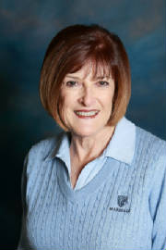
  CONNIE MERLIS
  SEPTEMBER 1-30, 2013 MOST IMPROVED GOLFERS
   |  |  |  | Starting |  | Ending
   |  | Name |  | Index (Hdcp) |  | Index (Hdcp) |  | Factor
  1 |  | Bev Letter |  | 10.6 (12) |  | 9.3 (11) |  | 1.061
  2 |  | Christina Templeton |  | 10.7 (12) |  | 9.9 (11) |  | 1.037
  3 |  | Lisa Shaw |  | 15.6 (18) |  | 14.8 (17) |  | 1.030
  4 |  | Fran Delashaw |  | 30.7 (35) |  | 29.5 (34) |  | 1.029
  5 |  | Teresa Whitney |  | 32.5 (37) |  | 31.3 (36) |  | 1.028
   |  | ( ) = Handicap converted from red tees.
  ~ RULES CHAIRMAN ~
  Patti Stringer
  PATTI STRINGER
  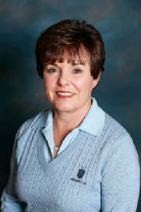
  RULES CHAIRMAN
  Monday Night Football
  Ladies,
  Monday night football has started and the Men’s Grill is the place to watch it! There will be plenty of food and drink available and if you wear pink and you will get a free drink. Some of the proceeds from the football pool will go to Breast Cancer Awareness.
  Bring your spouse and your friends or just yourself. It starts at 5:00 pm. The menu will include chips & salsa, chile, cornbread, chicken wings salad, fruit, cheese and veggies. Cost is 12.99++. There will also be some drink specials.
  See you there!
  Calling all Couples!
  Are you are interested in playing couples golf and sharing a drink and maybe dinner afterwards? Sunday, November 10th, we will have our first couples’ only sweeps. Put your own foursome together or ask the Pro Shop to try and pair you with another couple. Play just for fun or add a little spice and play the 18 hole Stableford game below. It is your choice!
  All that is required is that you are a couple (one man and one woman) and that you play as a foursome, if you are competing. You will need to secure your own tee time and hopefully you will arrange to finish around cocktail hour and maybe even stay for dinner.
  The team buy in will be 20.00 per couple. You must notify the Pro Shop before teeing off that you want to participate in the game and the tees you will be playing. All putts must be holed if you are competing. You may play just for fun if you wish as the buy in is strictly optional. Scrip will be awarded to 1/3 of the field.
  Hope to see you all at the bar afterwards!!
  Bev Letter
  PHOTOS
  Be sure to look at all our pictures
  on our Costco website.
  The login account is: marbellalc@yahoo.com
  The password is: 4marbella
  
  PHOTOGRAPHER
  ~ PK Jenican ~
  Please see our Photo Gallery at Costcophotocenter.com
  e-mail: marbellalc@yahoo.com password: 4marbella. If you have any photos from any of the events, we can still upload onto the website. Please let us know.
  If you order pictures to be picked up from Costco, use Mary Kay's name for the account!
  Anyone desiring a copy of a photo, please contact me with a description of the photo and I will gladly E-Mail you a copy. PK Jenican: P.k@camoves.com
  Past 2010/2013 Newsletters
  Thank you for visiting our web site!

You'll need Skype Credit

