Ladies Golf Club of Marbella
FROM THE RED TEES

  HOME
  2012 LCOM BOARD
  FROM THE RED TEES
  PHOTO GALLERY
  2012 CALENDAR
  ABOUT LCOM
  FORMS
  PAST NEWSLETTERS
  Chairman, Jill Blurton-Jones
  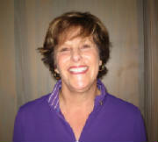
  November Newsletter
  Hope you all had a fun Halloween….. I ate way. Too much candy! Tonight we can look forward to hopefully getting an hours extra sleep, but the sad thing is that it gets dark earlier……well, we golfers are usually early risers!
  I hope you all enjoyed the WSCGA Foundation tournament.It looks like we raised about $1800. Thanks to our co-ordinators Patti Stringer, Celia Francese and Suzi Olsen who did an outstanding job.
  Our nomination committee worked hard on getting an Executive Board for 2013. I would like to thank Joey Knudson and her committee,Tina Russell, P.K.Jenican, Suzi Olsen & Carol McLaughlin, for their hard work and perseverance. Next month at our December General Meeting on December 6, the new committee will be installed. I look forward to handing over my gavel to Bev Letter who will be taking over the responsibilities of Chairman.
  Sadly one of the proposed slate of officers was Dani Ratkelis who lost her fight with cancer last week. She died peacefully in her sleep. There was a Memorial for Dani held by her family on Monday, November 5 at Marbella to celebrate Dani’s life. She kept such a brave face on things, allowing us to see only her vibrant personality and not her struggle with her disease. She will be missed greatly, as she was so much an integral part of our Ladies Club and a stickler for Rules!
  In England, Monday, November 5 (Guy Fawkes night) is still celebrated with fireworks and a huge bonfire. The story goes that Guy Fawkes wasn’t happy about the politics in the country, so he tried to blow up the Houses of Parliament, but failed… We Brits still celebrate the failure to blow up parliament. It is customary to make a Guy (usually made out of straw, similar to a scarecrow) and set him alight on top of a huge bonfire, and sing songs and roast sausages (bangers) around the fire!
  I wanted to let you all know that the Giving Tree is up and running in the Ladies Locker room thanks to the help of Marcia Smith, P.K. Jenican, Maria Barger and Lisa Shaw. Please don’t forget to take a tag and write your name in the book. Thank you in advance for your continued generosity.
  Finally please sign up for the Guest Day on Thursday, November 29. This will be our last LCOM event for the year, other than our General Meeting on Thursday, December 6th. At the meeting, we will be installing the officers for 2013, and my 2 year commitment as Chairman will soon be over! I have enjoyed the experience, though truthfully there have been a few bumps in the road……luckily I have had a very capable Executive Committee willing to help me with LCOM matters, and keep me on the straight and narrow. I wanted to personally thank Carol McLaughlin, Helen Helbing, Nancy Cleeremans, Sally Orgera, Barbara Behrens, Karen Jordan, Lori Bickel & Maxene Weinberg for all their support. Dani Ratkelis was my Rules Co-ordinator (even though Dani is no longer here she has been and will continue to be my conscience….we might have disagreed about the English Health system or about the Europeans winning the Ryder Cup, but she always gave me a “no nonsense” answer to any questions to do with the Ladies Club of Marbella.). I will miss her tremendously, she fought so bravely till the end, and her articles on Rules and Etiquette were amusing and very much to the point.
  As it says on page 21 under ByLaws in our booklets “The purpose of the Ladies Club shall be to promote fellowship, friendly competition and sociability and good sportsmanship associated with the game of golf.” I have tried to follow this statement and fulfill its aims for our Ladies Club, and even though I will be taking a back seat next year, I will continue to support LCOM to the full.
  See you on the golf course.
  Jill Blurton-Jones
  MEMBERSHIP
  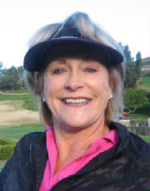
  CAROL MCLAUGHLIN
  CAROL MCLAUGHLIN
  We Currently Have 101 Full Members
  32 Handicap Only 0 Junior Members
  Total 133 Members
  NOVEMBER BIRTHDAY’S
  Birthday Winner - Jane Demeter
  Tricia Bauumgardner
  Jane Demeter
  Janet Ichinose
  Cheryl Marquis
  Sue Pebley
  Lisa Shaw
  WSCGA TOURNMENTS
  NOVEMBER
  11/12 (M) Tournaments of Champions 1 The Rivera, Pacific Palisades
  Sign up 9/7-10/19
  ***All details posted in Ladies Locker room
  JOIN THE LADIES CLUB:
  CONTACT Carol McLaughlin 949 212-0570 begin_of_the_skype_highlighting 949 212-0570 FREE end_of_the_skype_highlighting
  cjmestates@gmail.com.
  ~ WSCGA ~
  November 1, 2012
  FIRST PLACE GROSS
  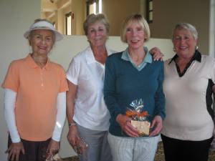
  Ginny Vincent, Diane Siegel,Linda Travis & Patsy Dryer
  FIRST PLACE NET
  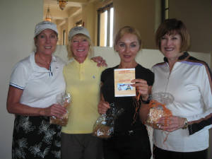
  Beverly Stinson, Carol Pugmire, Xeniya Bauman & Connie Merlis
  SECOND PLACE GROSS
  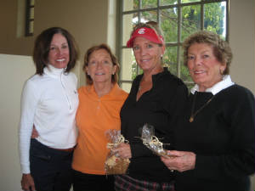
  Barbara Behrens, Ingrid Reuland, Shana Martensen & Celia Francese
  SECOND PLACE NET
  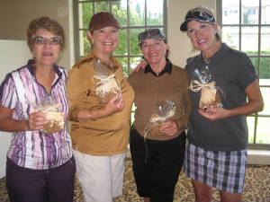
  Maria Barger, Tina Russell, Georgianna Hales & PK Jenican
  CLOSEST TO FLAGSTICK #4
  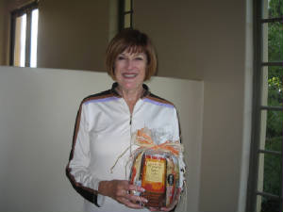
  Connie Merlis
  CLOSEST TO FLAGSTICK #11
  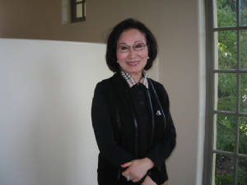
  June Kim
  MAJOR TOURNAMENTS
  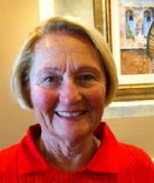
  Sally Orgera
  Major Tournaments
  ~
  Sally Orgera~
  The WSCGA Tournament on Nov. 1 was the last Major Tournament of the year. It was a big success in that we were able to give around $1800 to the charity.
  Our thanks go out to Patti Stringer, Suzi Olsen and Celia Francese for doing such a wonderful job on putting the tournament together. Wonderful job!
  Sally Orgera
  Major Tournaments
  ~ PLAY DAYS ~
  ~ Barbara Behrens ~
  PLAYDAY CHAIRPERSON
  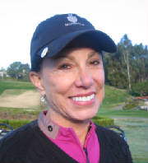
  Barbara Behrens
  I want to thank Marcia Smith and Carolyn McGuire for being October hostesses!
  November hostesses are PK Jenican, Nancy Tall and Jaisoo Bahng.
  October Low Gross winner was Susan Taylor with a 76.
  Low Net winners were Susan Taylor and Barbara Behrens with 69.
  LADIES I need your HELP !!!
  I will post a sign-up sheet for the 2013 Play Day Hostesses. Please sign-up to help with putting on our Thursday Play Days.
  It really isn't that much work and with 3 "helpers" every month, it is really easy....I will be available to help
  each and every one of you sooooo PLEASE sign-up....Thank You so very much....Barbara
  MaxeneWeinberg
  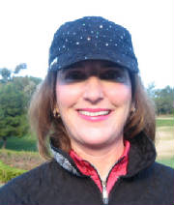
  ~GUEST DAYS~
  Maxene Weinberg
  Ladies,
  Our final Guest Day of 2012 will take place on November 29th. Please try and get your guests signed up as early as possible, as there are other clubs having guest days that same day. You can invite 1-3 guests and the cost is $45/player.
  We'll have a fun day of golf to jump-start the holiday season!
  Maxene
  GUEST DAYS 2012
  GUEST DAY
  NOVEMBER 29
  HOLIDAY GUEST DAY
  Lori Bickel
  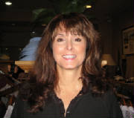
  Nine Holers
  ~Lori Bickel~
  2012 has been a fabulous year and it is ending with so many of the Niners handicaps reaching fun new lows. Congratulations on a job well done girls! Wishing everyone a wonderful Thanksgiving Holiday. We all have been blessed to have so many wonderful people in our lives, a beautiful course to golf on and the sunniest State in the USA for practicing our game. Life is good! Give Thanks!
  HANDICAP
  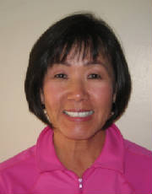
  Karen Jordan
  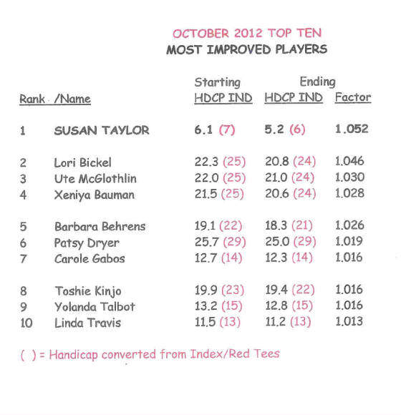
  DANI RATKELIS
  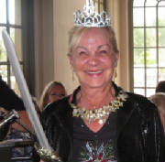
  RULES CHAIRMAN
  IN LOVING MEMORY
  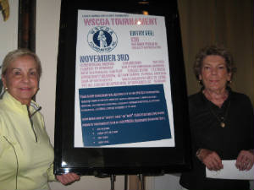
  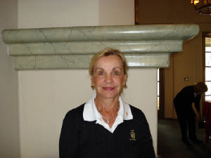
  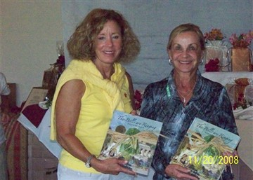
  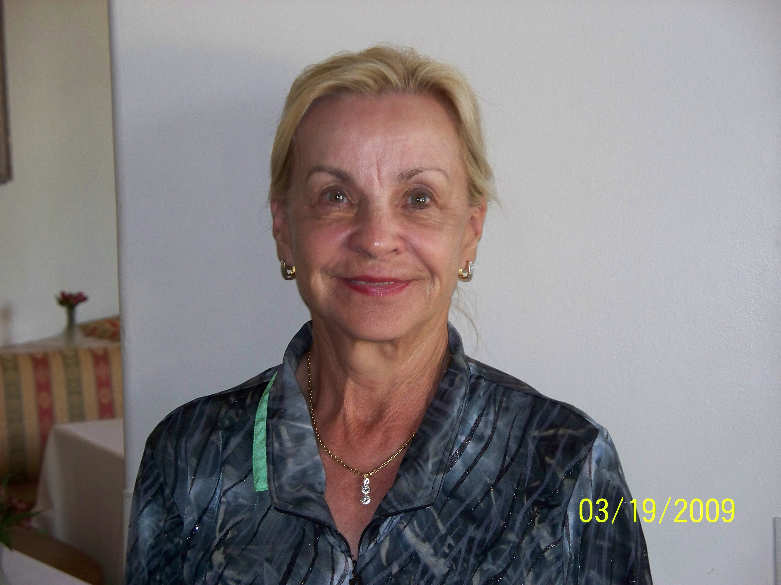
  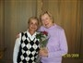
  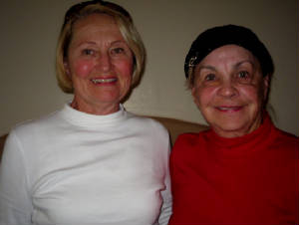
  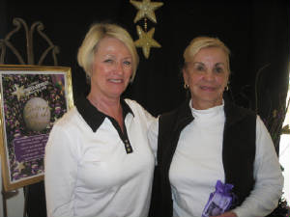
  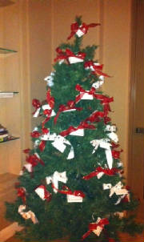
  2012 MARBELLA GIVING TREE
  For our Giving Tree this year, the Marbella
  Ladies club will be supporting a deserving Military family of 7. We also will be supporting the Orange County Interval house which supports local crisis shelters and centers for Domestic violence.
  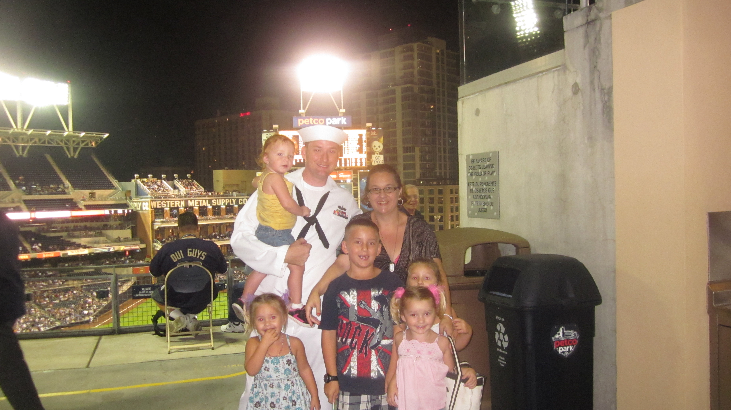
  Meet the Wells family. Father Ben Wells is an instructor in the US Navy for “Mine Detection.” He recently received an award at a Petco Park ceremony and has re-enlisted for another six years. He has a wife and five small children, ages 8, 5, twins 4, and a 2 year old, who do not get to see too much of him. They were quite excited and appreciative to hear that we had adopted them for Christmas. They will be thankful for anything.
  
  PHOTOGRAPHER
  ~ MARIA BARGER ~
  Please see our Photo Gallery at Costcophotocenter.com
  e-mail: marbellalc@yahoo.com password: 4marbella. If you have any photos from any of the events, we can still upload onto the website. Please let us know.
  If you order pictures to be picked up from Costco, use Mary Kay's name for the account!
  Anyone desiring a copy of a photo, please contact me with a description of the photo and I will gladly E-Mail you a copy. Maria Barger: parteebar@cox.net
  Past 2010/2012 Newsletters
  Thank you for visiting our web site!

