Ladies Golf Club of Marbella
FROM THE RED TEES

  HOME
  2013 LCOM BOARD
  FROM THE RED TEES
  PHOTO GALLERY
  2013 CALENDAR
  ABOUT LCOM
  FORMS
  PAST NEWSLETTERS
  ~CHAIRMAN ~
  Chairman
  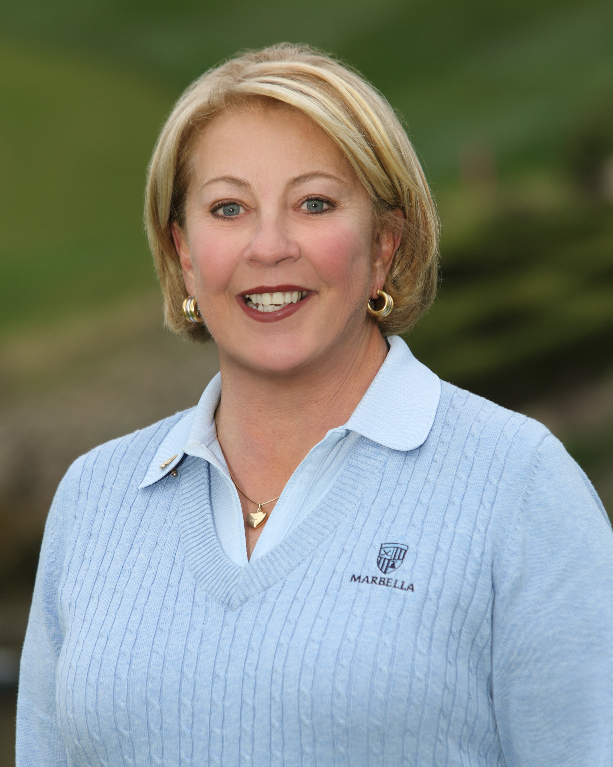
  Bev Letter
  Bev Letter
  MAY NEWSLETTER
  Spring has sprung and our golf course is looking better and better. As the conditions have improved so has our golf. Our Ladies’ Team has had two matches so far and we are currently in first place gross and in the hunt for net also. It is far from over but we are pretty fired up right now and looking forward to our remaining matches. Our captains, Linda Travis and Carole Gabos have done a wonderful job of leading our team and hopefully our wins will continue.
  The course should be in great shape for our next big tournament, the Senior Championship. It will be held on June 4 and June 6th. Susan Taylor is the Chairman and she has some very fun and different things planned so I hope that all of you youngsters who are at least 60 years of age will sign up for this one. It is guaranteed to be a lot of fun.
  Another great event scheduled for June is our Getaway to Maderas on June 12th.
  We will meet at Marbella and enjoy a bus ride to San Diego County where we will shotgun off at 9:30 am. Elizabeth Thiergartner will be arranging food and wine for the bus ride. The cost for the golf is regularly 170.00 but Maderas has agreed to let Marbella play for 110.00. They will be providing us with a box lunch. The total cost for the golf, lunch, and bus ride is estimated to be less than 150.00. The only catch is that the Ladies’ Club has to send off a nonrefundable deposit. We will not be able to refund you for any cancellations made after May 9th. You may arrange your own foursome or ask Elizabeth to pair you up. She will make every effort to accommodate you. We need a minimum of 25 ladies so PLEASE, PLEASE SIGN UP ON FORE TEES ASAP.
  For those of you who were not at General Meeting, our Ladies’ Locker Room will be getting some new furniture as American Golf has contracted with a designer who plans on giving it a fresh new look. Additionally, the restrooms on the golf course will get a fresh coat of paint as well as new vanities and mirrors.
  All in all, these are exciting times for us at Marbella and we should all look forward to a great summer ahead.
  ~ MEMBERSHIP ~
  Sherri Romito
  MEMBERSHIP
  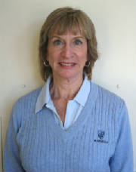
  SHERRI ROMITO
  The Ladies Club Roster consists of 96 regular members and 29 handicap only members.
  Birthdays for the month of May are:
  Susan Taylor May 4
  Kathy Williams May 5
  Debbie Narajowski May 12
  Nancy Tall May 12
  Susan Cole May 15
  Jeri Rimel May 18
  Betty Ann Martin May 19
  Elizabeth Thiergartner May 21
  The winner of the drawing for the discount in the pro shop was Nancy Tall.
  WSCGA Tournaments
  WSCGA OPEN PLAY DAY
  Monday June 3, 1013 at Santa Barbara Golf Club. Entry dates are April 8-May 20.
  Tournament information is posted in the locker room along with entry forms.
  JOIN THE LADIES CLUB:
  CONTACT: Sherri Romito 949-248-2453 begin_of_the_skype_highlighting 949-248-2453 FREE end_of_the_skype_highlighting sromito@aol.com
  GENERAL MEETING
  May 2, 2013
  FIRST PLACE
  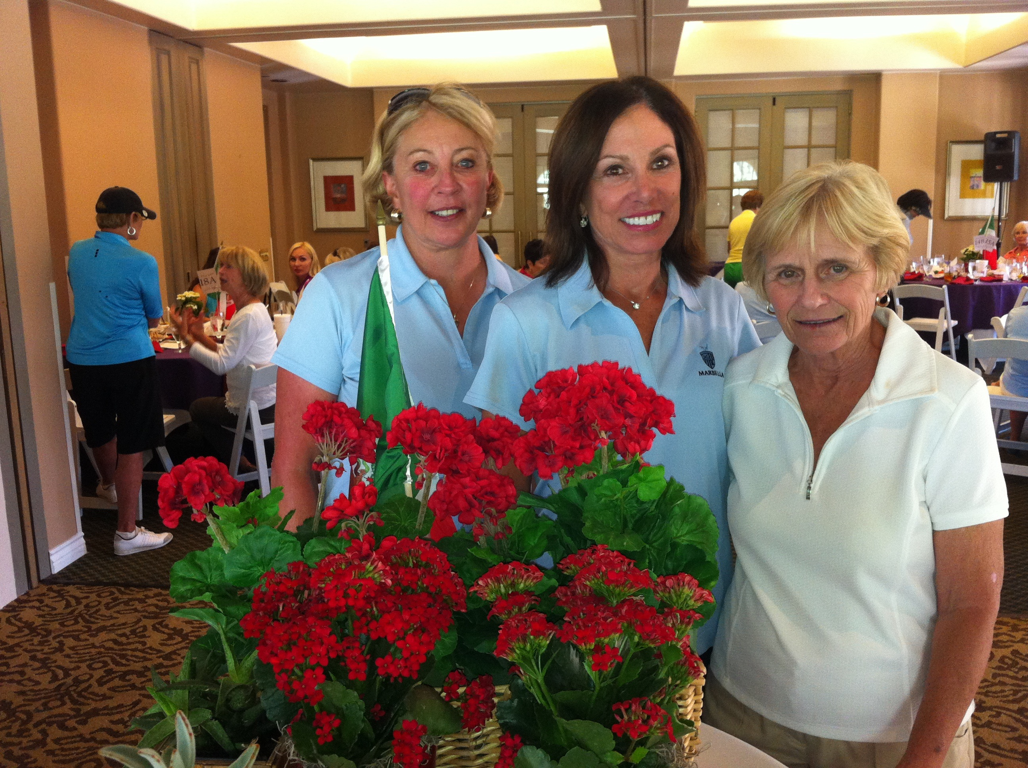
  Bev Letter, Barbara Behrens & Carolyn McGuire
  SECOND PLACE
  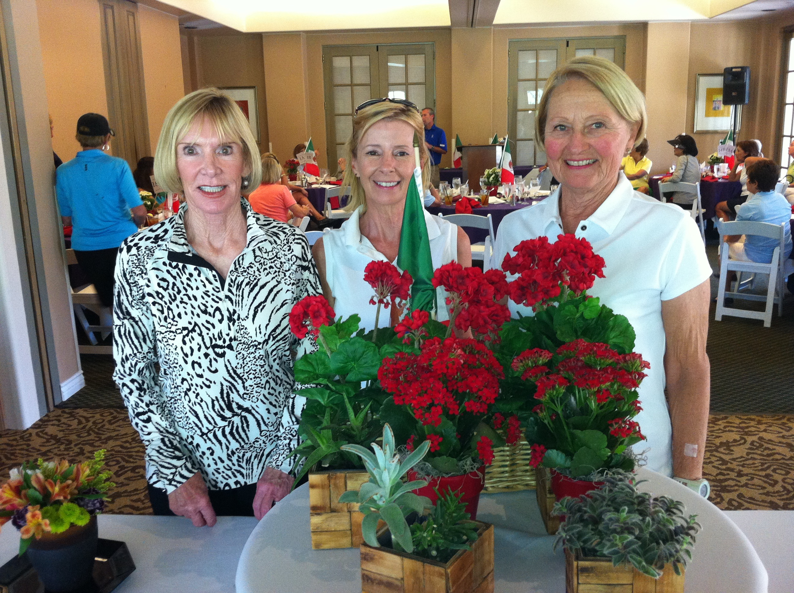
  Linda Travis, Jane Demeter, Carol McLaughlin &Sally Orgera
  THIRD PLACE
  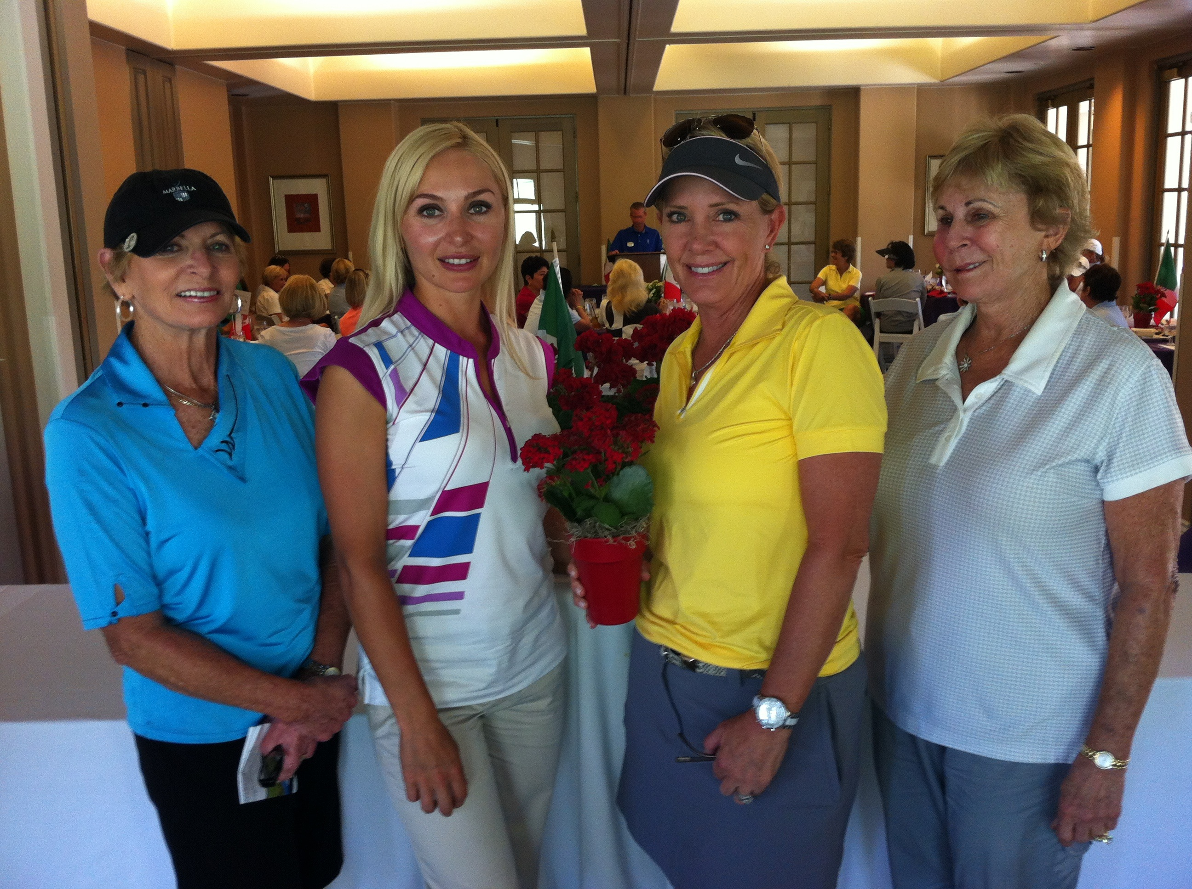
  Judy Davis,Xeniya Bauman,Diane Siegel & Shana Martensen
  ~ MAJOR TOURNAMENTS ~
  Yolanda Talbot
  MAJOR TOURNAMENTS
  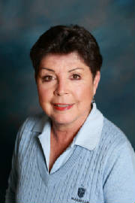
  YOLANDA TALBOT
  LADIES’ SENIOR CLUB CHAMPIONSHIP
  Well, we’re gaining on it – sign ups, that is! We now have 11 brave “young” 60 plus year olds signed up for our June 4th and June 6th tournament. But we need many more! Susan Taylor has some fun awards planned and there will be Gross and Net payouts depending on the size of the field. So let’s go out there and have some fun! We will be using the LI for the year from 5/15/12 to 5/15/13. Be sure to sign up for both days. I’ll be callin’ if I don’t see your name on there soon!! Look for the poster in the locker room.
  Yolanda Talbot
  SENIOR CLUB CHAMPION
  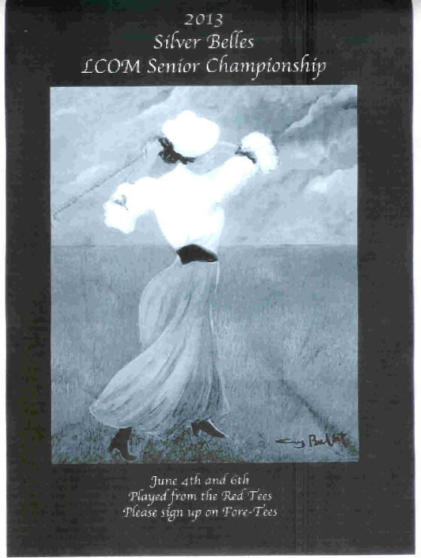
  Chairman Susan Taylor
  This tournament is open to all those who turn 60 years young by the
  first day of competition,
  provided you have posted 6 rounds of golf (18 holes) on Play Days,
  General Meeting Days,
  Guest Days, Tournaments and Team Play (maximum of 2) with in one year
  prior to the Tournament!
  We would love to see a great turnout for this event - sign up on
  Foretees today!
  ~ PLAY DAYS ~
  Barbara Behrens
  PLAYDAY CHAIRPERSON
  
  Barbara Behrens
  Ladies... Please note I posted in the locker room the Low Gross and Low Net
  winners so far this year....Again, I will request that the Pro Shop make a game
  card and posting card, for our Thursday Play Days. Please turn in your "game"
  card to the Pro shop. Post your scores and put your card in the drawer next to computer. If you pick-up, please mark an "X" and take your maximum score.
  I want to THANK Patsy Dryer for her help in the April & May General Meeting centerpieces. She does a beautiful job. Please remember the "Young" ladies will have a Play Day on June 6th starting at 8:00 am. Please sign up on foretees for
  General Meeting Day. If you have any questions, please call me.
  ~GUEST DAYS ~
  Nancy Tall
  GUEST DAYS CHAIRMAN
  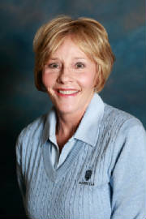
  NANCY TALL
  ATTENTION LADIES:
  Don't forget to sign up for our next guest day!
  It's May 23rd and its going to be so much fun.
  "BOOM IT AND BLOOM IT". Call and get 1-3 guests and sign up on four tees. If you have any problem with finding a guest, please call Maxene or myself and we will find you someone.
  The price is $45.00 which includes continental breakfast, snacks at the turn, lunch and prizes. Please sign up by May 21st.
  Thanks,
  Nancy Tall
  ~ HANDICAP ~
  Connie Merlis
  HANDICAP
  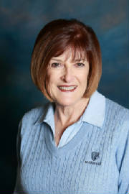
  CONNIE MERLIS
  April 1-30, 2013 MOST IMPROVED GOLFERS
   |  |  |  | Starting |  | Ending
   |  | Name |  | Index (Hdcp) |  | Index (Hdcp) |  | Factor
  1 |  | Susie Olsen |  | 16.2 (18) |  | 11.8 (13) |  | 1.185
  2 |  | Sue Pebley |  | 8.0 (9) |  | 5.6 (6) |  | 1.136
  3 |  | Bev Letter |  | 13.1 (15) |  | 10.9 (12) |  | 1.096
  4 |  | Maxene Weinberg |  | 21.5 (25) |  | 19.3 (22) |  | 1.070
  5 |  | Sally Orgera |  | 17.3 (20) |  | 15.4 (18) |  | 1.069
   |  | ( ) = Handicap converted from red tees.
  ~ RULES CHAIRMAN ~
  Pattie Stringer
  PATTI STRINGER
  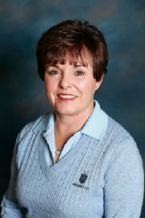
  RULES CHAIRMAN
  GETAWAY
  LCOM Members:
  Please join us for lots of fun and a bus ride as the LCOM enjoys a getaway and a day of golf at beautiful Maderas golf course in San Diego County.
  Elizabeth Thiergartner has arranged for us to hop on a bus leaving from Marbella on June 12th. She will make certain that we are entertained on the way down and back. Ladies will bring your own snacks and wine for the bus ride.
  We will have a 9:30 shotgun start at Maderas and they will provide us with a box lunch during the round. The staff at Maderas has assured us that we will not be disappointed.
  Maderas golf course has been voted number one course in San Diego County for seven years; One of the 100 best courses for women in the country; in the top seven courses in California; and just this past month in the top 100 courses in the US.
  The green fees alone are usually 170.00. Maderas will allow us to play for 110.00. The cost for the box lunch with tax and gratuity will be 16.00. The number of ladies riding will determine the cost of the bus. Providing your own transportation is not an option. The estimated total is 150.00 or less.
  Because Maderas is in such demand, they are requiring that we send a nonrefundable deposit and guarantee a minimum number of ladies.
  In order to make this work for us, we will have to know well in advance exactly how many people want to go. If you are interested, please sign up on Fore Tees now.
  Please note in the event you cancel after May 9th, you will be charged the full amount. No REFUNDS will be made after May 9th. We must have at least 25 ladies signed up by May 9th. IF YOU WANT TO GO, PLEASE, PLEASE SIGN UP ASAP.
  THE NUMBER OF PLAYERS ALLOWED IS LIMITED SO FIRST COME, FIRST SERVE!!!!
  
  A LITTLE BIT COUNTRY
  LCOM MEMBER-MEMBER TOURNAMENT
  JULY 11 & JULY18
  ~Judy Davis, Tina Russell & Joey Knudson~
  Grab your “Par-dner”…and swing to a “Little Bit Country”. Rope in your par-dner now for this fun two- day eclectic cuz y’all are goin’ to have a boot kickin’ good time!
  This is the most fun-filled, and stress-free tournament of the year. For those of you on the fence, let us explain. If you and your par-dner can play both days, you have four chances to get one best ball on each hole. If one of you can only play one of the days, fine. If you both can only play one day, not a problem as far as signing up, but good luck. You don’t even have to play on the same day. There will be two flights from the Red Tees, with Gross and Net Prizes, and of course, a tee prize for everyone. As usual the 10-stroke differential applies with a maximum handicap of 36.
  Sign-ups will be available next month.
  
  FALL TEAM
  Fall team sign-ups have begun. We already have 20 ladies interested in playing in our fun fall league. To play you must have a handicap between 15-30 as of Aug. 1st. We will play four matches at some great courses, Santa Ana, Mesa Verde, Mission Viejo and Yorba Linda. All games will take place between August 20th and Sept. 10th.
  Please look for the sign-up sheet in the locker room. Come and join us, don’t miss out on all of the fun.
  Your Captains
  Carolyn McGuire
  Marcia Smith
  Spring Team 2013
  Our team is half way through the season and we are thrilled to say we have been playing very well and remain in contention for a shot at the playoffs. We have played Newport at home and away and won net at both courses and gross at home. We have played Shady at Shady (course is closed so they hosted us at Marbella) and we won both gross and net. We will host Shady Canyon on the 9th and then play at Bella on the 13th and then finish our regular season hosting play Bella on the 21st. Our gals have played some spectacular golf and have won very close matches. We thank them all for their commitment to team, stellar play, friendship and fun and look forward to more of the same for the next few weeks.
  Cheers!
  Linda Travis and Carole Gabos
  
  PHOTOGRAPHER
  ~ PK Jenican ~
  Please see our Photo Gallery at Costcophotocenter.com
  e-mail: marbellalc@yahoo.com password: 4marbella. If you have any photos from any of the events, we can still upload onto the website. Please let us know.
  If you order pictures to be picked up from Costco, use Mary Kay's name for the account!
  Anyone desiring a copy of a photo, please contact me with a description of the photo and I will gladly E-Mail you a copy. PK Jenican: P.k@camoves.com
  Past 2010/2013 Newsletters
  Thank you for visiting our web site!

You'll need Skype CreditFree via Skype

