Ladies Golf Club of Marbella
FROM THE RED TEES

  HOME
  2013 LCOM BOARD
  FROM THE RED TEES
  PHOTO GALLERY
  2013 CALENDAR
  ABOUT LCOM
  FORMS
  PAST NEWSLETTERS
  Chairman
  
  Bev Letter
  MARCH NEWSLETTER
  Once again the LCOM has shown what a great organization we are. The first and hopefully annual Chairmen’s Cup was a huge success and the spirit of friendship and fellowship was exceedingly apparent. It truly was a gathering of new and old friends and has set the stage for a wonderful 2013 season.
  The LCOM and the past Chairmen of the Ladies’ Club hosted the event on Tuesday night. We had the entire South Bar to ourselves. Ray Felix did his usual magic with the food serving baby lamb chops, salmon cones, cheese, and crackers. He also provided us with two wonderful servers, Alex and Bryn, who never stopped pouring wine and could not have been more accommodating. The festivities continued, the trophy was displayed, and Birdie and Eagle teams were randomly drawn for a fun day of golf on Thursday. And what a fun day it was! On the golf course you could hear the Eagles and Birdies, each cheering for their respective teams. Golf was followed with yet another fabulous meal in an absolutely beautifully decorated Board of Governor’s room.
  When all was said and done, we lifted our glasses to the Eagles who were victorious. The trophy will proudly display the Eagles as winners until next year when the Birdies promise to get their revenge.
  Congratulations and thank you to all who participated. It was great fun! I would also like to thank our Handicap Only members for joining us. Those of you who RSVP’D your regrets, I can only say we missed you, and you missed a very fun time.
  The LCOM Board will be putting our heads together to see what other new and exciting events we can conjure up and your ideas and suggestions are always welcome. In the meantime, please check you calendars as we all look forward to our next great event. Our one-day Mini Member guest tournament is on March 14th. Patsy Dryer and her committee consisting of Carol Pugmire, Linda Fryling, Joey Knudson, and Tina Russell chair this event. It is guaranteed to be one of the best events of the year and something you won’t want to miss.
  As always, the success of our events is based on our participation. If you want to play and are in need of a guest, please let someone on the committee know. They will make every attempt to find you someone to play with.
  MEMBERSHIP
  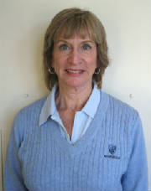
  SHERRI ROMITO
  MEMBERSHIP Sherri Romito
  The Ladies Club Roster consists of 97 regular members and 32 handicap only members.
  Birthdays for the month of March are:
  Nancy Naeve March 1
  Mary Frances Winton March 1
  Susi Olsen March 5
  Connie Merlis March 16
  Marilyn Weber March 17
  Lisa Hwang March 19
  Lori Bickel March 24
  Carol Pugmire March 25
  Kerry Holtrust March 31
  The winner of the drawing for the discount in the pro shop was .
  Connie Merlis
  WSCGA Tournaments
  OPEN PLAY DAY
  This event will be held March 25 at Sierra Lakes Golf Club in Fontana. Entry dates are February 4th to March 11th.
  Tournament information is posted in the locker room along with entry forms.
  JOIN THE LADIES CLUB:
  CONTACT: Sherri Romito 949-248-2453 begin_of_the_skype_highlighting 949-248-2453 FREE end_of_the_skype_highlighting sromito@aol.com
  GENERAL MEETING
  MARCH 7, 2013
  RAINY DAY
  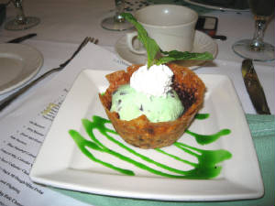
  Dessert was great!
  Fun at lunch
  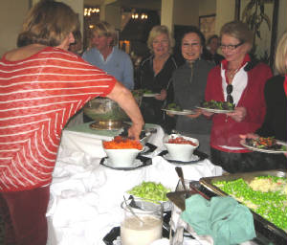
  Great meeting!
  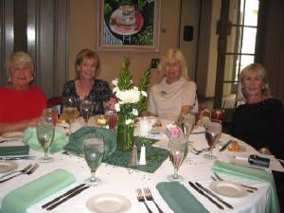
  Shana & Jean
  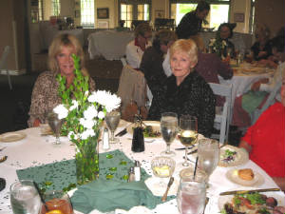
  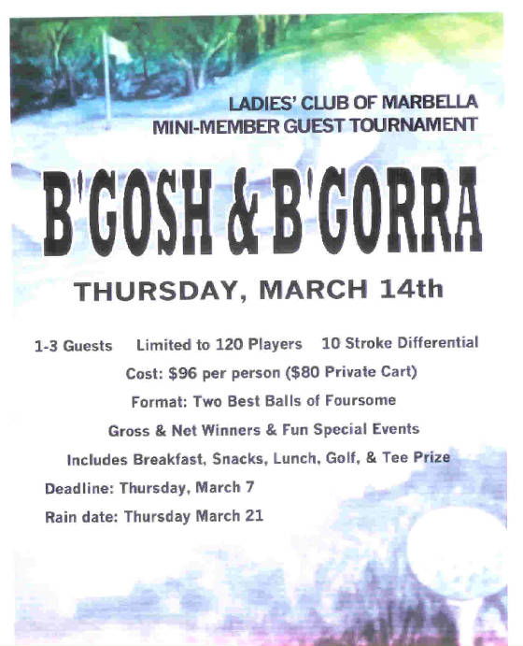
  MAJOR TOURNAMENTS
  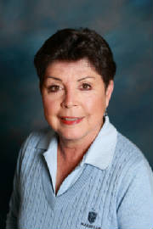
  YOLANDA TALBOT
  Major Tournaments
  ~Yolanda Talbot
  ~
  MAJOR TOURNAMENT CHAIRMAN
  Yolanda Talbot
  No Report this month!
  ~ PLAY DAYS ~
  ~ Barbara Behrens ~
  PLAYDAY CHAIRPERSON
  
  Barbara Behrens
  Greetings Ladies...We are still "fine tuning" playdays with the Pro shop, and I thank you for your patience.
  I will request that when they are making out the game cards with handicaps, that they make a duplicate
  "posting" card with handicaps. Please adjust if you play from the red/white tees. I will be away from Mar 28th
  thru April 11th so Thursday and Saturday playday results will not be tallied until after I return. Elena Miller and
  Judy Davis are unavailable during that time also.
  Barbara Behrens
  GUEST DAYS CHAIRMAN
  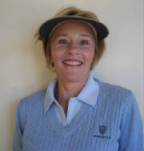
  NANCY TALL
  ~GUEST DAYS~
  Nancy Tall
  Ladies,
  Please sign up for our upcoming Mini-Member, Thurs. March 14th. B"Gosh & B'Gorrah is going to be an outstanding event!! Please fill out the registration card which is in the basket next to the beautiful poster along with your check for $96.00 PER PLAYER. Make your check payable to LCOM. Give your card and check to the locker room attendant. Please sign up on Fore Tees. If you have any questions or need a guest please call Patsy Dryer or Carol Pugmire.
  Attention Ladies:
  Due to the lack of interest, the Home and Home with Yorba Linda has been canceled. It was scheduled for March 28th at Marbella and April 2nd at Yorba Linda.
  Nancy Tall
  Maxene Weinberg
  TIME FOR NINE
  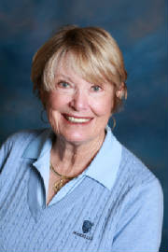
  TINA RUSSELL
  ~TIME FOR NINE ~
  Tina Russell
  I just thought if you were not at the General Meeting in February there are several things you should all be aware, especially if you are new, have been out of town or haven’t been able to play yet this year. The February and March newsletters have a lot of information. I am enjoying playing just nine with you on Tuesdays.
  As you probably know now, the LCOM Board passed a motion that there will be no more NINE HOLE group. All members will now belong to the LADIES’ CLUB OF MARBELLA. The time slots on FORETEES will be opened to all LCOM members.
  • I will continue to be signing up on Tuesdays at the 9:30 on FORETEES (9 H) and then staying for lunch.
  • Time for Nine has always been available on Thursdays and we encourage you to play then as well. If there are three or more that play nine on Thursdays, they are entitled to have script for Low Net, unless If it is General Meeting day, a Guest Day or other Tournament. When you sign up on FORETEES just indicate 9H. The Pro Shop is handling the Play Day cards now so pick up and return your cards to them. Script for the week will be posted in the locker room as usual.
  • If you have not played for script on Thursdays, or if the Thursday before was General Meeting Day, Guest Day, or other Tournament, you are welcome to sign up with the Saturday Working Women’s group in the Lottery and are eligible for script.
  This is going to be a great year for the LCOM. If you have not been able to play because of an injury or your busy schedule, I encourage you to get back into the swing of things. If you have any questions don’t hesitate to call me, or e-mail me at tinarussell60@gmail.com. Kerry Holtrust and Cheryl Marquis are both available to answer any questions.
  HANDICAP
  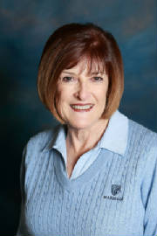
  CONNIE MERLIS
  HANDICAP
  ~Connie Merlis ~
  2012 MOST IMPROVED GOLFER
  Congratulations to Susan Taylor who went
  from a 6.8 index (8 handicap) to a 4.9 index
  (6 handicap).
  FEBRUARY 1-28, 2013 MOST IMPROVED GOLFERS
   |  |  |  |  | Starting |  | Ending
   |  | Name |  |  | Index (Hdcp) |  | Index (Hdcp) |  | Factor
  1 |  | Jane Demeter |  |  | 20.6 (24) |  | 17.9 (20) |  | 1.090
  2 |  | Heidi Bae |  |  | 26.9 (31) |  | 25.2 (29) |  | 1.046
  3 |  | Connie Merlis |  |  | 16.4 (19) |  | 15.3 (17) |  | 1.040
  4 |  | Ginny Vincent |  |  | 24.2 (28) |  | 22.8 (26) |  | 1.040
  5 |  | Sally Orgera |  |  | 18.9 (22) |  | 17.9 (20) |  | 1.033
  6 |  | Sonya Mahony |  |  | 23.4 (27) |  | 22.3 (25) |  | 1.032
  7 |  | Patty Collins |  |  | 11.2 (13) |  | 10.5 (12) |  | 1.031
  8 |  | Karen Jordan |  |  | 11.5 (13) |  | 10.8 (12) |  | 1.031
  9 |  | Shana Martensen |  |  | 14.0 (16) |  | 13.3 (15) |  | 1.028
  10 |  | Nancy Cleeremans |  |  | 18.3 (21) |  | 17.5 (20) |  | 1.027
   |  | ( ) = Handicap converted from red tees.
  GOLFERS WITH 100 OR
  MORE ROUNDS POSTED
  IN 2012
  1 |  | Jane Demeter |  |  | 205
  2 |  | Bev Letter |  |  | 147
  3 |  | Karen Jordan |  |  | 135
  4 |  | Sonya Mahony |  |  | 129
  5 |  | Linda Travis |  |  | 128
  6 |  | Susan Taylor |  |  | 117
  7 |  | Sally Orgera |  |  | 113
  8 |  | Carolyn McGuire |  |  | 104
  9 |  | Jill Blurton-Jones |  |  | 103
  10 |  | Diane Siegel |  |  | 101
  11 |  | Connie Merlis |  |  | 100
  CONGRATULATIONS TO JAISOO BAHNG WHO HAD A HOLE-IN-ONE ON HOLE 4
  ON FEBRUARY 24.
  PATTI STRINGER
  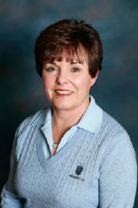
  RULES CHAIRMAN
  2012 & 2013 rules books are available. If you need
  one, just let me know!
  Patti Stringer
  Golf Etiquette-#2 -SPEED OF PLAY
  As we often take a look at other golfers on the course and notice the
  things they do to slow down play, so should we take a look at ourselves. When
  we do take an honest look at ourselves, we often discover we're doing some of
  the same things to slow down play that we're complaining about others
  doing.
  1. It is the
  group's responsibility to keep up wit the group in front of them.
  2. A
  golfer should always be ready to play their shot when it is deemed to be her
  turn.
  3. Always
  move to your ball as soon as possible, without disrupting or getting in the way
  of another golfer. You should be thinking about club selection, target, wind
  conditions and so
  forth while waiting for others to hit.
  4. When 2
  players are riding in a cart, drive to the first ball and drop off the first
  player with her choice of clubs. The second player should proceed in the cart
  to her ball. After
  the first player hits her stroke, she should begin walking toward the cart as
  the second golfer is playing.
  5. If you
  are unsure whether your ball has come to rest "out of bounds", or may be "lost", immediately hit a "provisional" so that you won't have to return to the spot
  to replay the
  shot.
  6. Never
  delay making a stroke because you're having a conversation with a playing
  partner. Put the conversation on hold, make your stroke, then pick up the conversation
  again.
  7. When
  playing on or near the green, you should leave your bag or cart in such a
  position as will enable quick movement off the green and towards the next
  tee.
  8. Begin
  reading the green and line up your putt as soon as you reach the green. Don't
  wait until it is your turn to putt to start the process of reading the
  green.
  9. When the
  hole is completed, players should immediately leave the putting green. Fill out
  the scorecard on the next tee box.
  10. On a
  cart-path-only day, take more
  than one club with you when you walk from the cart to your ball. Getting to
  the ball only to find out you do not have the right club is a huge
  time-waster.
  11. Although
  the rules state that a golfer has five minutes to search for a lost ball one
  should never take this much time if not playing in a serious tournament
  situation. Upon hitting a ball into a questionable location,
  first take note of its location (identifying a tree, rock or landmark), then
  take 2 minutes to search for that ball after arriving in the general location where it
  landed.
  12. If you
  hit your ball into a water hazard, choose one of the options for a water hazard.
  Then, after you have played you shot and it is no longer your turn, you may
  then retrieve your
  ball from the hazard.
  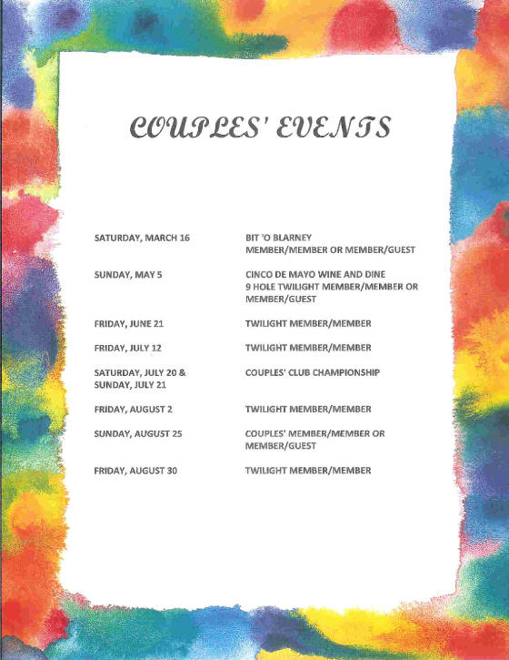
  
  PHOTOGRAPHER
  ~ PK Jenican ~
  Please see our Photo Gallery at Costcophotocenter.com
  e-mail: marbellalc@yahoo.com password: 4marbella. If you have any photos from any of the events, we can still upload onto the website. Please let us know.
  If you order pictures to be picked up from Costco, use Mary Kay's name for the account!
  Anyone desiring a copy of a photo, please contact me with a description of the photo and I will gladly E-Mail you a copy. PK Jenican: P.k@camoves.com
  Past 2010/2013 Newsletters
  Thank you for visiting our web site!

