Ladies Golf Club of Marbella
FROM THE RED TEES


JANUARY
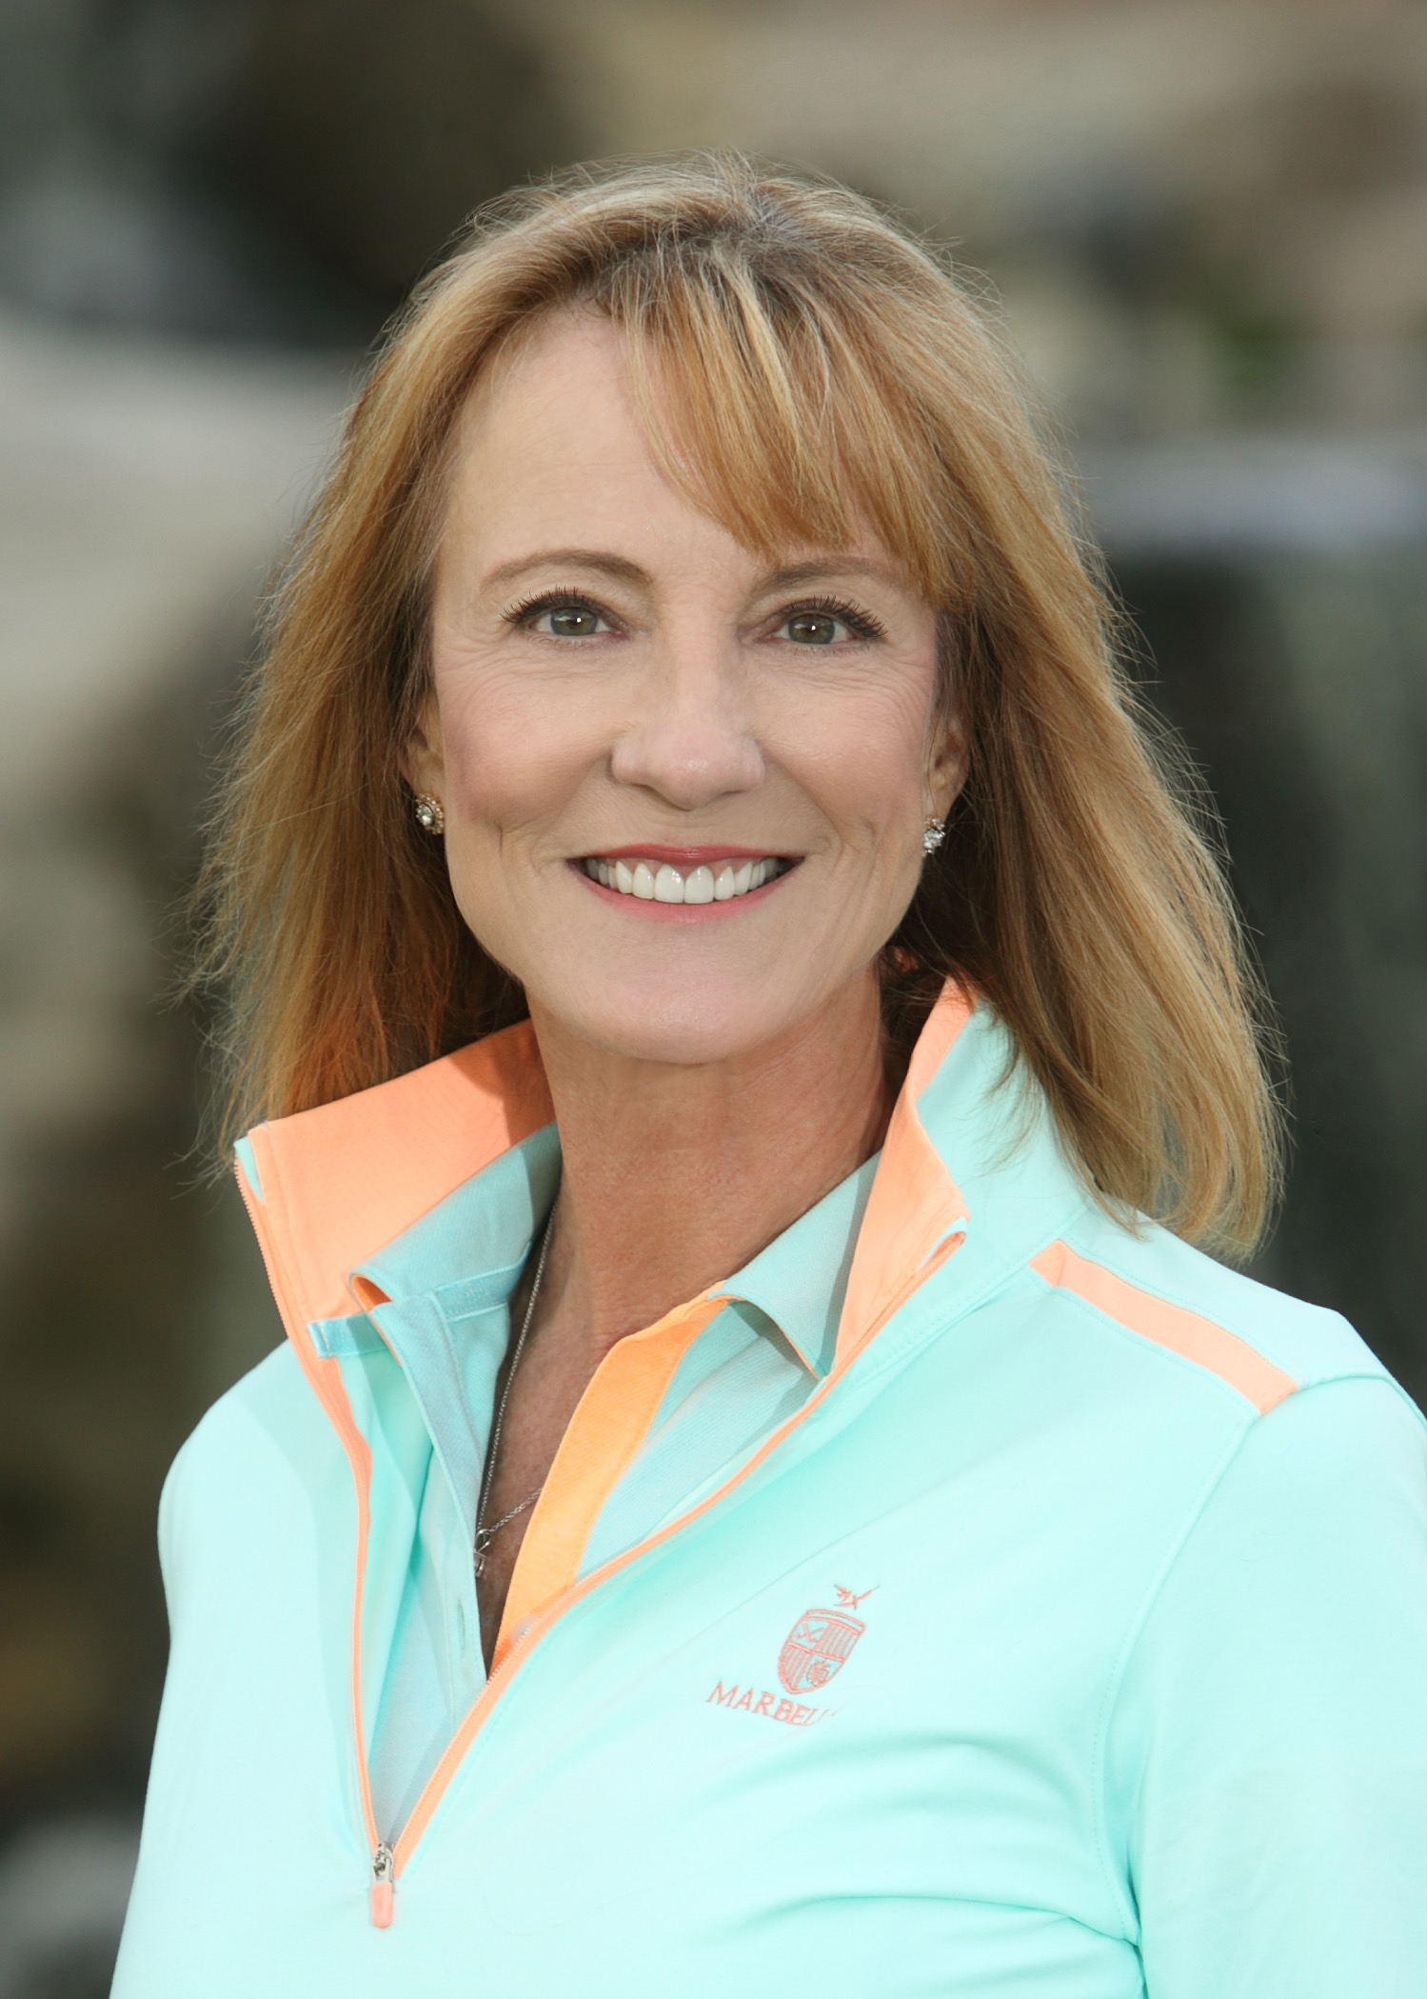
NEWSLETTER

~CHAIRMAN~
Nancy Cleeremans

Hi Everyone
Happy New year to you all.

I am excited to serve as your Chairperson again this year. You have voted in a great Executive Committee and I am looking forward to working with them.

We welcomed in 10 new members to our group last year. Several have already become quite active in our group. This year, I would like to build a sense of community and team spirit. I would like to strongly encourage participation of our newer members to join in and take part in our events on a regular basis. I ask you to support me in making them feel welcome and supported in their efforts.
In addition to Teresa’s welcome letter, I want to personally contact each of our new members and invite them to play with me on one of our playdays, and urge them to come to our General Meetings and become involved.

Speaking of participation, we still have no one to chair the Mission Belles, Club Championship or the Net Challenge. According to our by-laws, the only tournament we are required to have is the Club Championship and that will be held this year on May 26, May 31 and June 2. I have spoken with several people who would love to participate on these committees, but don’t feel they know enough to head them up yet. That’s where we need our more “seasoned” members to step in. I promise to find you anyone you would need to assist you. If we want a Mission Belles this year, work needs to start on it ASAP.

January is a slow month in term of activities but plans are now being started for the Guest Day in February and the Chairmen’s Cup, the first week of March.

I learned something new lately. If you play on a GM day, that payout doesn’t count against scrip used in the playdays. Therefore you can still play on Saturday that week and be eligible scrip. Hopefully we can get more players on Saturdays.

Hopefully, the rain will let up and we can get out on the course

Have fun.
Nancy

~MEMBERSHIP~
Teresa Whitney

The Ladies Club is at 98 members.
Our Handicap Only members number 22.
We also have 2 Junior Memberships.
Birthdays for the month of January are:
Noel Helm January 3rd
Kathy Lyons January 3rd
Ginny Vincent January 10th
Betsy Woodhouse January 13th
Carla Dotoli Jenkins January 16th
Tina Russell January 19th
Kay Hockema January 24th
Phyllis Goldstein January 27th
Patty Collins January 28th
Carol Mclaughlin Chenault January 30th
Linda Farley January 31st

The winner of the birthday discount certificate to be used in the pro shop was Tina Russell Congratulations Tina, and Happy Birthday ladies!

WSCGA Tournaments & other info
WSCGA Senior Championship - Monday and Tuesday, February 8 & 9, 2016 El Caballero Country Club Entry dates: December 4, 2015 – January 15, 2016

*All information for tournaments are posted in the locker room along with entry forms.

If you haven’t picked up your 2016 roster, you can pick it up in the ladies locker room!!
A couple of changes to make in your books:
Mary Kay Minner’s - cell # 949-290-5275 (everything else the same)
Cecile Wren, new address – 16 Novilla, Laguna Niguel, 949-429-7676 (home#)

~PLAY DAYS~
Sally Orgera

Happy 2016 to all. I want to stress to all players that on play days please X out when you pick up without playing out the hole. Please do this on both the posting card & if applicable the game card. Be sure you withdraw from the game if you X out on a hole that counts in the game. This helps to accurately name the gross & net weekly winners as well as the game winners. Your group will be responsible for making a posting card for your group as groups change so frequently that it is not practical for the pro shop to put them together. Please check your pops on your weekly game card as they are not always completely accurate.

January Playdays

1/14 game is Low Gross/Low Net
1/21 game is "Hate 'Em"
1/28 game is Par 4's

~HANDICAP~
Sonya Mahony

DECEMBER 2015 MOST IMPROVED

NAME STARTING ENDING
INDEX (HDCP) INDEX (HDCP

- Marcia Smith 20.5 (23) 19.5 (22)

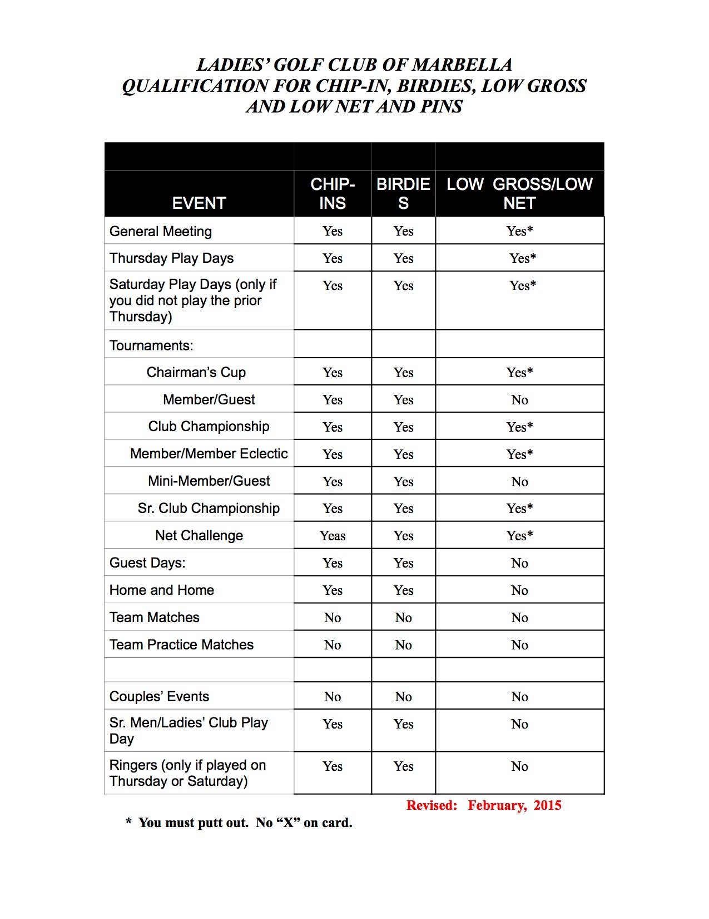
2. Linda Travis 14.9 (17) 14.1 (16)

3. Shana Martensen 11.9 (14) 11.3 (13)

4. Toshie Kinjo 16.6 (19) 16.3 (18)

5. Maria Barger 29.3 (33) 28.6 (33)

Handicap converted from red tees

CONGRATULATIONS!!!!!

SONYA MAHONY

2015 MOST IMPROVED GOLFER

STARTING ENDING
INDEX INDEX

1. Sonya Mahony 22.0 (25) 15.5 (18)


2. Teresa Whitney 30.3 (35) 25.2 (29)

3. Jill Blurton-Jones 16.3 (19) 13.4 (15)

4. Susan Purel 24.2 (28) 21.2 (24)

5. Kathy Lyons 18.9 (22) 16.7 (19)

~RULES CHAIRMAN~
Jean Kelly

The 2016 Edition of USGA Rules of Golf has been released and the principle changes are listed in the beginning of the book on pages 13-15. One change which will affect a few of us is as follows:

Rule 14-1b. Anchoring the Club
A new Rule is introduced to prohibit anchoring the club, either "directly" or by use of an "anchor point" during the making of a stroke.
This new rule can be found on Page 80 and is as follows:

Rule 14-1b. Anchoring the Club

In making a stroke, the player must not anchor the club, either "directly" or by use of an "anchor point."

Note 1: The club is anchored "directly" when the player intentionally holds the club or a gripping hand in contact with any part of his body, except that the player may hold the club or a gripping hand against a hand or forearm.

Note 2: An "anchor point" exists when the player intentionally holds a forearm in contact with any part of his body to establish a gripping hand as a stable point around which the other hand may swing the club.

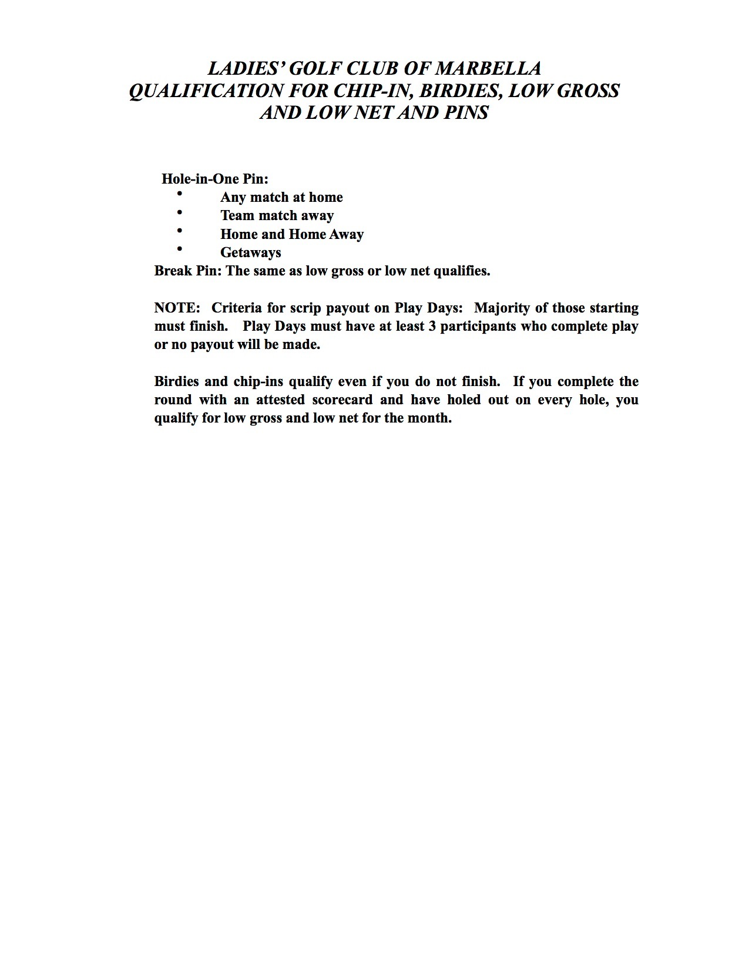
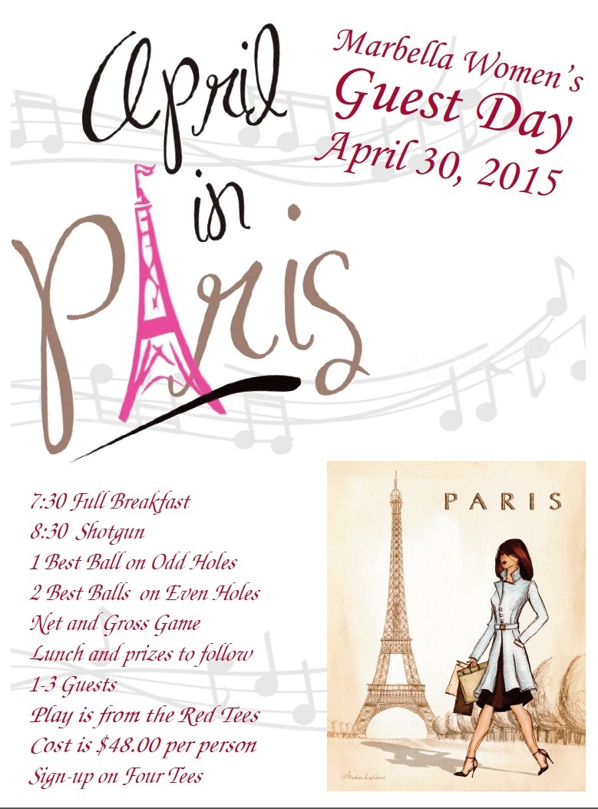



~PHOTOS~
Cecile Wren

Hi Ladies,
If you would like to order pictures of the different Ladies' Club activities, please use our Costco site.

Log onto:
http://costcophotocenter.com/album/
Login account # is marbellalc@yahoo.com

The new Password is: 4lcomgolf (This is 4LCOMGOLF in lower caps)
When you go to pick up the pictures, you need to use Mary Kay Minner's name. She opened this account for us and photos will be under her name.



