Ladies Golf Club of Marbella
FROM THE RED TEES

  HOME
  2013 LCOM BOARD
  FROM THE RED TEES
  PHOTO GALLERY
  2013 CALENDAR
  ABOUT LCOM
  FORMS
  PAST NEWSLETTERS
  ~CHAIRMAN ~
  Chairman
  
  Bev Letter
  Bev Letter
  JULY NEWSLETTER
  Summer is definitely here and the golf course is looking better than ever. Vince Zellefrow and his staff certainly deserve kudos for doing a fabulous job. Our fairways have more grass on them than they have had in years. Vince and his staff will be planting 3-5 trees a month and will begin to plant and water the slopes of the golf course. They will also continue to seed the areas around the greens on a regular basis. With a few more months of heat ahead of us, we can look forward to great golf course conditions for our upcoming Club Championship as well as our Mission Belles Member Guest tournament. You may sign up for both of these events on Foretees and if you are in need of a guest for our Mission Belles tournament, Karen Jordan will assist you in finding someone.
  Last week we were on the road again with our Member Member tournament. Joey, Tina, and their entire committee deserve mega kudos for running our most popular tournament of the year. As always this committee did a fabulous job. They left not a stone unturned carrying out the western theme. The food, drink, and camaraderie, not to mention the Zumba dancing, made this event one of our best. Dolly Parton even made a surprise appearance.
  As most of you know a few of us have been working with American Golf and their design expert to refurbish the Ladies’ Locker Room. In order to have some seating available now, we have moved some temporary chairs and tables into the Locker Room. While everything is not going to be new, we are very excited about what is to come. We anticipate the completion date to be around the end of August. At the time of installation the locker room will be closed and only access to lockers and showers will be allowed. We appreciate your understanding during this time as we look forward to a new and fresh looking locker room.
  Please remember to fill out your American Golf Member survey which was emailed to everyone on July 1st. If you did not receive it, it very well may be in your trash or junk mail. Your responses to the survey are very important to American Golf as well as your Advisory Board. Please take a moment to fill it out and return it.
  Bev
  ~ MEMBERSHIP ~
  Sherri Romito
  MEMBERSHIP
  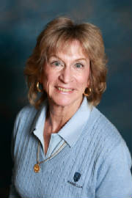
  SHERRI ROMITO
  Membership Sherri Romito
  The Ladies Club Roster consists of 90 regular members and 27 handicap only members.
  Birthdays for the month of July are:
  Sheryl Sauer July 17
  Jean Kelly July 19
  Maxene Weinberg July 20
  June Kim July 27
  The winner of the drawing for the discount in the pro shop will be determined next month.
  WSCGA Tournaments
  Tournament information is posted in the locker room along with entry forms.
  Two-Person Event
  August 8 at Pauma Valley Country Club. Entry dates are May 31-July 12, 2013.
  36-Hole Stroke Tournament
  August 19 & 20 at Las Posas Country Club. Entry dates are June 14 to July 26
  WSCGA Foundation Golf Fundraiser
  Monarch Beach Golf Links on Thursday September 12
  JOIN THE LADIES CLUB:
  CONTACT: Sherri Romito 949-248-2453 949-248-2453 FREE sromito@aol.co
  GENERAL MEETING
  JULY 18, 2013
  LOW GROSS OVER THE FIELD
  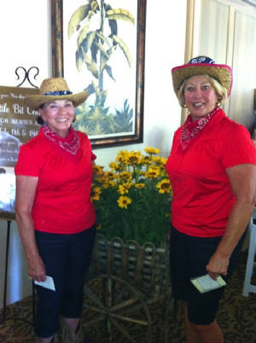
  GEOGIANNA HALES & BEV lETTER
  LOW NET OVER THE FIELD
  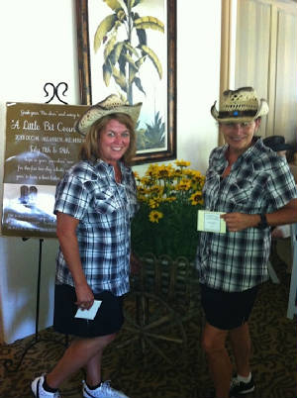
  FRAN DELASHAW & NOEL HELM
  FIRST PLACE GROSS FLIGHT A
  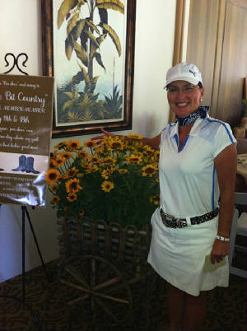
  CHERYL MARQUIS & LORI HATHAWAY
  FIRST PLACE GROSS FLIGHT B
  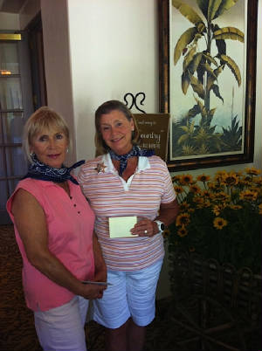
  UTE MCGLOTHLIN & NANCY CLARK
  FIRST PLACE NET FLIGHT A
  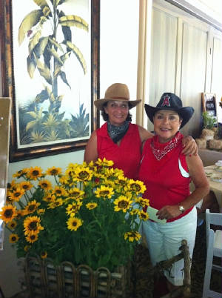
  SUZI OLSEN & YOLANDA TALBOT
  FIRST PLACE NET FLIGHT B
  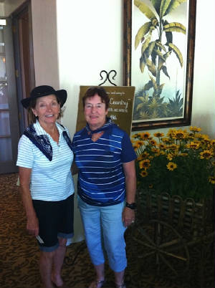
  INGRID REULAND & HELEN HELBING
  SECOND PLACE GROSS FLIGHT A
  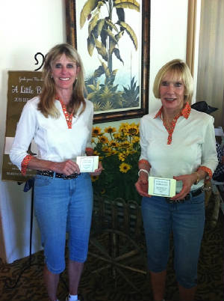
  SUSAN TAYLOR & LINDA TRAVIS
  SECOND PLACE GROSS FLIGHT B
  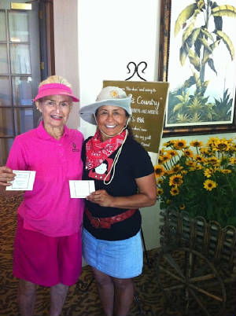
  GINNY VINCENT & KATHERINE SZEM
  SECOND PLACE NET FLIGHT A
  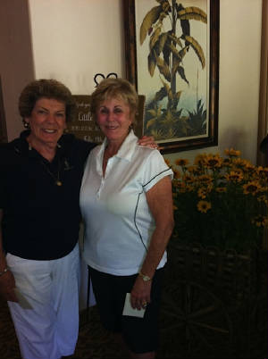
  CELIA FRANCESE & DIANE SIEGEL
  SECOND PLACE NET FLIGHT B
  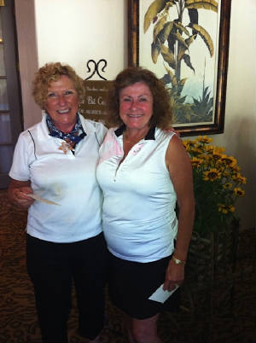
  TONI TAYLOR & BETTY MARTIN
  THIRD PLACE GROSS FLIGHT A
  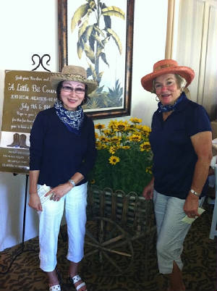
  JUNE KIM & PATTI COLLINS
  THIRD PLACE GROSS FLIGHT B
  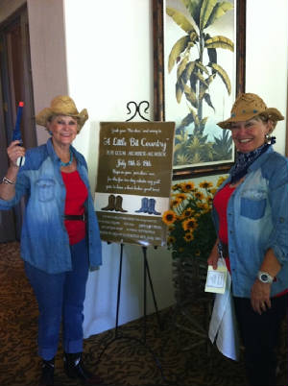
  JOEY KNUDSON & TINA RUSSELL
  THIRD PLACE NET FLIGHT A
  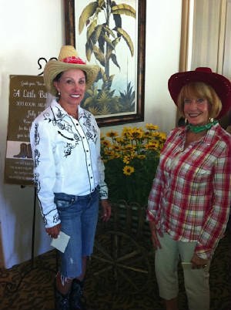
  BARBARA BEHRENS & SHERYL SAUER
  THIRD PLACE NET FLIGHT B
  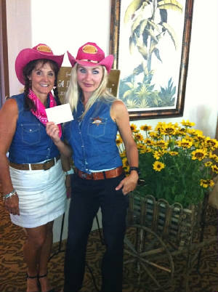
  LORI BICKEL & XENIYA BAUMAN
  LITTLE BIT OF COUNTRY
  2013 MEMBER-MEMBER TOURNAMENT
  Tournament Committee:
  Judy Davis, Joey Knudson, Tina Russell,
  Betsy Woodhouse & Kerry Holtrust
  We hope y’all had a great time at our LCOM HOEDOWN. Thanks to all the Par-dners who participated to make our tournament such a success and our congratulations to all the winners (listed below).
  It definitely was a “Bloody Mary Morning” on Day One starting with a little rain and ending with humid conditions. We could all hardly wait to “Get on the Road Again” on Day Two to see if we could improve our scores. Willie Nelson may have made the songs famous, but the Dixie Chicks and Dolly Partons from our LCOM were overheard singing on the fairways, “The life I love is playin’ golf with my friends.” That is exactly what this tournament is all ‘bout.
  Special thanks to all those that we roped in to help: our friend, Melissa Stultz, for her help decorating, Barbara Klotz for her role as a Cowgirl Ride Along, and Barbara Behrens for all her western props. We now know that boots are not just made for walkin’. No doubt y’all will be talking for some time about the amazing surprise guest appearance of Dolly Parton. She was definitely more than a little bit country.
  The Barn Doors finally opened after lunch and our special guest, Magdalena Lowance, gave us some great ideas on how to make exercise and country dancing a little more fun with some real Country Zumba. Hats off to all who gave it a try!
  We certainly can’t say enough about the roles the staff at Marbella took for helping turn our club into “A Little Bit Country”. Stephen Plummer and Mark McDonough really rolled up their sleeves to help us all “Walk the Line” in True Grit fashion. Bryn and Nicholas from Food & Beverage listened to all our requests and each did so much that we had one authentic Hoedown! Our chef Robert made sure we had a sampling of the best Western food ever. Our special thanks to Ted Axe for helping us fulfill our dreams of making Marbella “A Little Bit Country”, if only for a day.
  2013 MEMBER-MEMBER
  "A LITTLE BIT COUNTRY"
  OVER Y'ALL GROSS |  | Georgianna Hales & Bev Letter |  |  | 73x
  OVER Y'ALL NET |  | Noel Helm & Fran Delashaw |  |  | 55
  FLIGHT A | DIXIE CHICKS
   | 1st Place Gross | Cheryl Marquis & Lori Hathaway |  |  | 73x
   | 1st Place Net | Susie Olsen & Yolanda Talbot |  |  | 59
   | 2nd Place Gross | Susan Taylor & Linda Travis |  |  | 75
   | 2nd Place Net | Celia Francese & Diane Siegel |  |  | 60
   | 3rd Place Gross | Patty Collins & June Kim |  |  | 76
   | 3rd Place Net | Barbara Behrens & Sheryl Sauer |  |  | 61
  FLIGHT B | DOLLY PARTON
   | 1st Place Gross | Nancy Clark and Ute McGlothlin |  |  | 87
   | 1st Place Net | Ingrid Reuland & Helen Helbing |  |  | 60x
   | 2nd Place Gross | Ginny Vincent & Katherine Szem |  |  | 89
   | 2nd Place Net | Betty Martin & Toni Taylor |  |  | 60x
   | 3rd Place Gross | Tina Russell & Joey Knudson |  |  | 90
   | 3rd Place Net | Lori Bickel & Xeniya Bauman |  |  | 65
  CLOSEST TO PIN
   | Dixie Chicks: Hole #4 | Day One | Linda Travis |  | 4'
   | Dolly Parton: Hole #11 | Day One | Kerry Holtrust |  | 11'7"
   | Dixie Chicks: #11 | Day Two | June Kim |  | 7'7"
   | Dolly Parton: #4 | Day Two | Noel Helm |  | 33'
  DOLLY PARTON MADE A SURPRISE VISIT!
  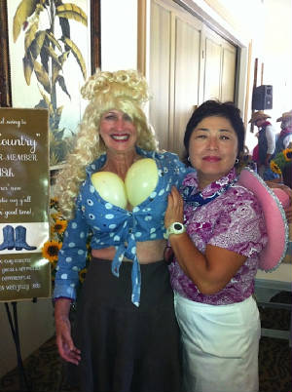
  ~ MAJOR TOURNAMENTS ~
  Yolanda Talbot
  MAJOR TOURNAMENTS
  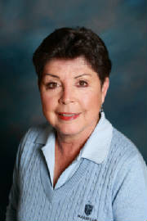
  YOLANDA TALBOT
  REMEMBER TO SIGN UP FOR THE LADY'S CLUB
  CHAMPIONSHIP!
  ~ PLAY DAYS ~
  Barbara Behrens
  PLAYDAY CHAIRPERSON
  
  Barbara Behrens
  Ladies...The Pro shop is doing a great job in helping with the Thursday Play Days. If
  you have any favorite games you like to play, please let me know.
  Thanks, Barbara
  ~GUEST DAYS ~
  Nancy Tall
  GUEST DAYS CHAIRMAN
  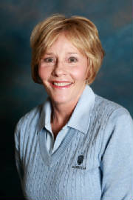
  NANCY TALL
  Hello ladies,
  Our next guest day will be November 14th.
  Look for details in future Newsletters!
  Nancy Tall
  ~ HANDICAP ~
  Connie Merlis
  HANDICAP
  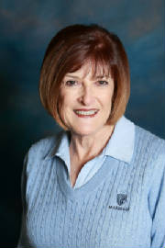
  CONNIE MERLIS
  JUNE, 2013 --- MOST IMPROVED GOLFERS
  Starting Ending
  Name Index (Hdcp) Index (Hdcp) Factor
  1 Linda Travis 11.7 (13) 10.1 (12) 1.072
  2 Toshie Kinjo 18.4 (21) 16.6 (19) 1.063
  3 Susan Taylor 4.4 (5) 3.6 (4) 1.051
  4 Karen Jordan 11.0 (13) 10.0 (11) 1.045
  5 Shana Martensen 11.6 (13) 10.6 (12) 1.044
  ( ) = Handicap converted from red tees
  ~ RULES CHAIRMAN ~
  Pattie Stringer
  PATTI STRINGER
  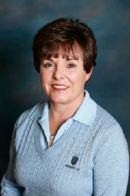
  RULES CHAIRMAN
  HOW MUCH DO YOU KNOW?-Rules Quiz
  1. In stroke play competition, the player must put an identification
  mark on his ball; if he fails to do so, he incurs a two stroke penalty.
  True or False
  2. In stroke play, a player returns his score card with a total score
  that is correct but with a score missing for one hole.
  a. The committee should allow him to enter he missing score.
  b. The committee should enter the missing score.
  c. He is disqualified.
  3. In stroke play, a player incorrectly substitutes a ball when
  dropping after taking relief from casual water. What is the ruling if
  he has not yet played a stroke with the dropped ball?
  a. He must mark and lift the substituted ball and replace the
  original ball.
  b. He must lift the substituted ball and drop the original ball.
  c. There is a two stroke penalty and the substituted ball is the
  ball in play.
  Answers
  1. False, Rule 6-5 - It is highly recommended but not required.
  2. He is disqualified, Decision 6-6d/1
  3. He must lift the substituted ball and drop the original ball, Rule
  20-6
  CLUB CHAMPIONSHIP
  The Ladiesʼ Club of Marbella
  Welcomes your participation in the
  2013 Ladiesʼ Club Championship
  August 6, 7, and 8
  Championship Flight
  Ladies Championship White Tees
  54 holes of stroke play
  Club Flight
  Ladiesʼ Red Tees
  36 holes of stroke play
  Joine the fun and excitement of this
  major event!
  Sign up on foretees
  Deadline July 30, 2013
  
  PHOTOGRAPHER
  ~ PK Jenican ~
  Please see our Photo Gallery at Costcophotocenter.com
  e-mail: marbellalc@yahoo.com password: 4marbella. If you have any photos from any of the events, we can still upload onto the website. Please let us know.
  If you order pictures to be picked up from Costco, use Mary Kay's name for the account!
  Anyone desiring a copy of a photo, please contact me with a description of the photo and I will gladly E-Mail you a copy. PK Jenican: P.k@camoves.com
  Past 2010/2013 Newsletters
  Thank you for visiting our web site!

