Ladies Golf Club of Marbella
FROM THE RED TEES

  HOME
  2012 LCOM BOARD
  FROM THE RED TEES
  PHOTO GALLERY
  2012 CALENDAR
  ABOUT LCOM
  FORMS
  PAST NEWSLETTERS
  Chairman, Jill Blurton-Jones
  
  January 2012
  I want to wish every one of you a happy and healthy New Year, may 2012
  be even better than 2011.
  On a very sad note I have to report that Dan Riker our General Manager
  will be leaving Marbella in mid-January. We wish him well in his new
  position as General Manager of the Golf & Golden Bear Club at Indigo
  Run, Hiton Head, S. Carolina. Lisa Webster will have left to start her
  nursing career & we will miss both Lisa & Dan greatly.
  Welcome to Ashley Loduca who has taken over Lisa’s position as Member
  Relations, and we hope that we will find a remarkably good replacement
  for Dan! I understand that they will be starting the interviewing
  process very soon. It will be hard to find another General Manager to
  fill Dan’s shoes as he has been so helpful to our Ladies Club and has
  looked after Marbella Country Club and all its staff and members with
  such dedication and support.
  Our calendar for 2012 is almost complete,with just a few vacancies
  needing to be filled...so if you haven't stepped up to the plate I
  would encourage you to please help out? We still need your help and
  input in making LCOM even better than it has been in the past, and we
  need new blood to add new ideas.
  We started off the New Year with lots of ladies playing golf in a par
  3 contest followed by our General Meeting and lunch. Thank you all for
  starting off the new year with such enthusiasm, I am excited to have a
  new board helping me, plus some remaining board members (Maxene, Lori &
  myself). We have many exciting fun filled guest days, tournaments and
  other events planned for 2012. Georgianna and her committee have
  kindly agreed to run a Ringer tournament again starting in mid July
  thru November, more details to follow.
  The first round of our President’s Cup starts on Valentine’s Day, so
  please sign up as soon as possible for this exciting tournament. The
  good thing about this tournament is that one can mess up 1 or 2 holes
  then tie a few holes, and then come back with a vengeance to win the
  match. It is a double elimination, NET tournament and all competitors
  have the chance to move up the ladder and win one of the flights on
  the final day, or be President’s Cup winner for 2012!
  Hoping to see you all on the course.
  Jill Blurton-Jones
  MEMBERSHIP
  
  CAROL MCLAUGHLIN
  MEMBERSHIP
  ~ Carol Mc Laughlin ~
  Looking forward to a Fabulous 2012.
  We currently have 109 Full Members, 29 Handicap Only & 3 Junior Members
  Total 133 Members.
  Newest member, Welcome Tammy Tucker
  WSCGA TOURNMENT Senior Championship Individual Stroke Play, Dove Canyon February 27-28 Entry dates TBD
  January Birthday's
  Kathy Lyons
  Jackie testman
  Noel Helm
  Tammy Curtis Happy BIRTHDAY
  Kay Hockema
  Phyllis Goldstein
  Besty Woodhouse
  Ginny Vincent
  Tina Russell
  Julie Roth
  Carol Mclaughlin
  ~ GENERAL MEETING ~
  JANUARY 5, 2012
  FIRST PLACE
  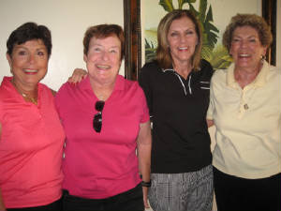
  Talbot, Helbing, Lawrence, & Francese
  SECOND PLACE
  
  Weinberg, Jordan, Barger & Woodhouse
  THIRD PLACE
  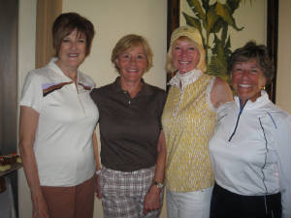
  Merlis, Tall, Pugmire & Danto
  CLOSEST TO THE PINS
  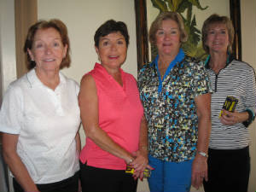
  Reuland, Talbot, Collins & Romito
  LOW NET FOR THE YEAR
  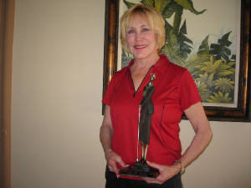
  Mary Kay Minner
  MOST IMPROVED FOR THE YEAR
  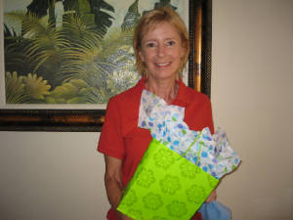
  Jane Demeter
  MAJOR TOURNAMENTS
  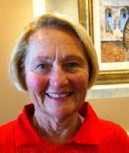
  Sally Orgera
  Major Tournaments
  ~
  Sally Orgera~
  I
  Help! Coming on feb. 14 is the beginning of the 1st round of the President's cup. We need bodies. Please,please sign up so we can make this a fun and successful tournament. The dates for it are :
  1st round-Feb 14-17; 2nd Feb 18-21; Qtr final Feb 23; semi-final Feb 28 and final Mar 1st.
  You can sign up in the locker room, call me or any member of the committee.
  Let's start this year off with a bang and let's all participate.
  LADIES’ CLUB MAJOR TOURNAMENTS
  2012
  PRESIDENT’S CUP ROUND 1 – FEBRUARY 14-17
  ROUND 2-FEBRUARY 18-21
  QUARTER FINALS-FEBRUARY 23
  SEMI-FINALS-FEBRUARY 28
  FINALS-MARCH 1
  J. DEMETER/C. PUGMIRE/
  COORDINATORS
  MEMBER/MEMBER
  ECLECTIC
  MARCH 15 AND MARCH 22
  J. KNUDSON/T.RUSSELL
  COORDINATORS
  LADIES’ SR. CLUB
  CHAMPIONSHIP
  JUNE 5 AND JUNE 7
  KAY WOOD
  COORDINATOR
  MINI-MEMBER/GUEST
  1-DAY
  JULY 19
  S. OLSEN/G. HALES
  COORDINATORS
  LADIES’ CLUB
  CHAMPIONSHIP
  ALL FLIGHTS - ROUND 1 – JULY 31
  CHAMPIONSHIP FLIGHT ONLY - ROUND 2
  AUGUST 1
  ALL FLIGHTS - FINAL ROUND – AUGUST 2
  COORDINATOR – TO BE DETERMINED
  SENIOR MEN’S & LADIES
  MIXER
  AUGUST 22
  COORDINATOR – JERI RIMEL
  THE MISSION BELLES
  MEMBER/GUEST 3-DAY
  SEPTEMBER 18, 19 & 20
  PK JENICAN/S.MARTENSEN
  COORDINATORS
  WSCGA SCHOLARSHIP
  TOURNAMENT
  NOVEMBER 1
  P. STRINGER/C. FRANCESE
  ~ PLAY DAYS ~
  ~ Barbara Behrens ~
  PLAYDAY CHAIRPERSON
  
  Barbara Behrens
  Ladies, welcome to the new year! Hope everyone enjoyed their holidays. Many thanks to our December hostesses: Patti Stringer. Marcia Smith and Sue Pebley. Our January hosteses are: Judy Davis, Kerry Holtrust and Carol Pugmire. We are grateful for all their hard work. We still need hostesses for June and July!
  Congratulations to Bev Letter, our low gross winner with a 76; and to Mary Kay Minner, our low net winner with a 63.
  Please remember to put your full name and tees played from on your game cards. Don’t forget to attest it. Just a reminder: If your game card is not filled out completely and you do not fill out the game sheet, you are not eligible for scrip. Also, the handicap entered on the scoring sheets is from the red tees. If you play other tees, IT IS YOUR RESPONSIBILITY to correct the score sheet. We are not doing this and it makes it very difficult and time consuming to flight by tees for prizes.
  We are still looking for Hostess volunteers for February, March, June and July of this year. There is a signup sheet next to the computer in the locker room.
  I am passing this responsibility torch to Barbara Behrens knowing she will do a terrific job. So from me I bid you “Thank You and Good Play!”
  Thank you and let’s have fun out there.
  Thursday December 8, 2011- GAME: “Middle Nine” 50% Handicap
  Red/White Flight (3 players)
  1st Place: Susan Taylor 33.5
  Red Flight1 (10 players)
  1st Place: Linda Travis 35
  2nd Place: P. Collins, B. Behrens, M. Smith 76
  Red Flight2 (12 players)
  1st Place: Joey Knudson 30.5
  2nd Place: Maria Barger 35
  3rd Place: C. Pugmire, S. Lawrence, D. Sowers 37.5
  Low Gross: Susan Taylor 83
  Low Net: Joey Knudson 73
  MaxeneWeinberg
  
  ~GUEST DAYS~
  Maxene Weinberg
  There is no guest day in January. Our first guest day of 2012 will be in May. I'll keep everyone updated the closer we get to May!
  LADIES’ CLUB GUEST DAYS 2012
  MAY 12
  CINCO de MAYO
  COUPLES’ MEMBER/GUEST
  MAY 24
  GUEST DAY
  JUNE 28
  GUEST DAY
  JULY 19
  MINI-MEMBER GUEST
  AUGUST 16
  GUEST DAY
  SEPTEMBER 18, 19 & 20
  MISSION BELLES MEMBER/GUEST
  OCTOBER 11
  GUEST DAY
  NOVEMBER 29
  HOLIDAY GUEST DAY
  Lori Bickel
  
  Nine Holers
  ~Lori Bickel~
  Wishes for a fantastic New Year from the Ladies Club Niners to all the Marbella Golfer gals!
  Congratulations to our Elizabeth Thiergartner for her hard work on the golf course this year and being awarded this year’s Most Improved for the Nine Holers.
  As for future plans, we will have a Valentines Game pairing the Niners with a few 18 hole participants for fun and prizes. Be on the lookout for information on the locker room bulletin board and sign ups. Keep smilin’!
  HANDICAP
  
  Karen Jordan
  ~Handicap~
  Karen Jordan
  Ladies' please remember to post at all courses
  Happy New Year, Ladies --- I look forward to serving as your Handicap Chair!
  An “informal committee” has been gathered to assist when needed. I feel very fortunate to have RONA KIPPER and MARCIA SMITH as back-up, along with the help of Assistant Pro, Stephen Plummer.
  Most Improved Players for December, 2011:
  Jane Demeter, 20.1 Handicap Index to 18.7 Handicap Index
  Celia Francese, 16.9 to 15.9
  Susan Taylor, 7.4 to 6.8
  REMINDER (if you’d like to do one less thing in 2012): Your Ghin # does NOT need to be listed on your scorecard anymore --- Pass it on! J
  Handicap-- Rona Kipper
  Most Improved Golfer for the year:
  Jane Demeter 22.7 18.7
  E. Thiergartner 4 0.4 3 4 . 7
  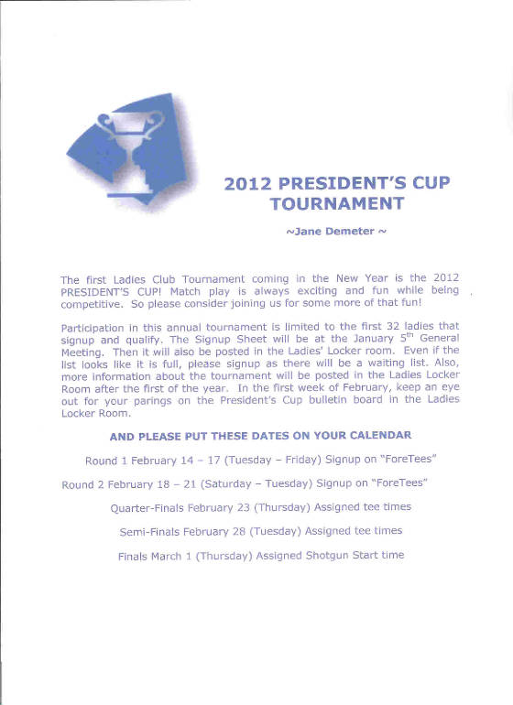
  DANI RATKELIS
  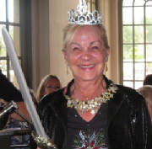
  RULES CHAIRMAN
  Following an exhaustive, four-year review of golf's 34 playing Rules by USGA and R&A, nine principal Rules have been amended to improve clarity and ensure penalties are proportionate. I will cover the changes in each newsletter.
  Rule 18-2b Ball moving after address. A new exception is added which exonerates the player from penalty if their ball moves after it has been addressed when it is or virtually certain that they did not cause the ball to move.
  For example, if it is a gust of wind that moves the ball after it has been addressed, there is no penalty and the ball is played from the new position.
  Ball in Hazard; Prohibited Actions (13-4).Exception 2 to this Rule is amended to permit a player to smooth sand or soil in a hazard at any time, including before playing from that hazard, provided it is for the sole purpose of caring for the course and Rule 13-2(IMPROVING LIE, AREA OF INTENDED STANCE OR SWING OR LINE OF PLAY) is no breached.
  Thank you, Ladies, for your contributions to our Giving Tree! It was a huge success again this year. Thank you, Lisa, for your hard work.
  Enjoy the photos below.
  
  Military Family
  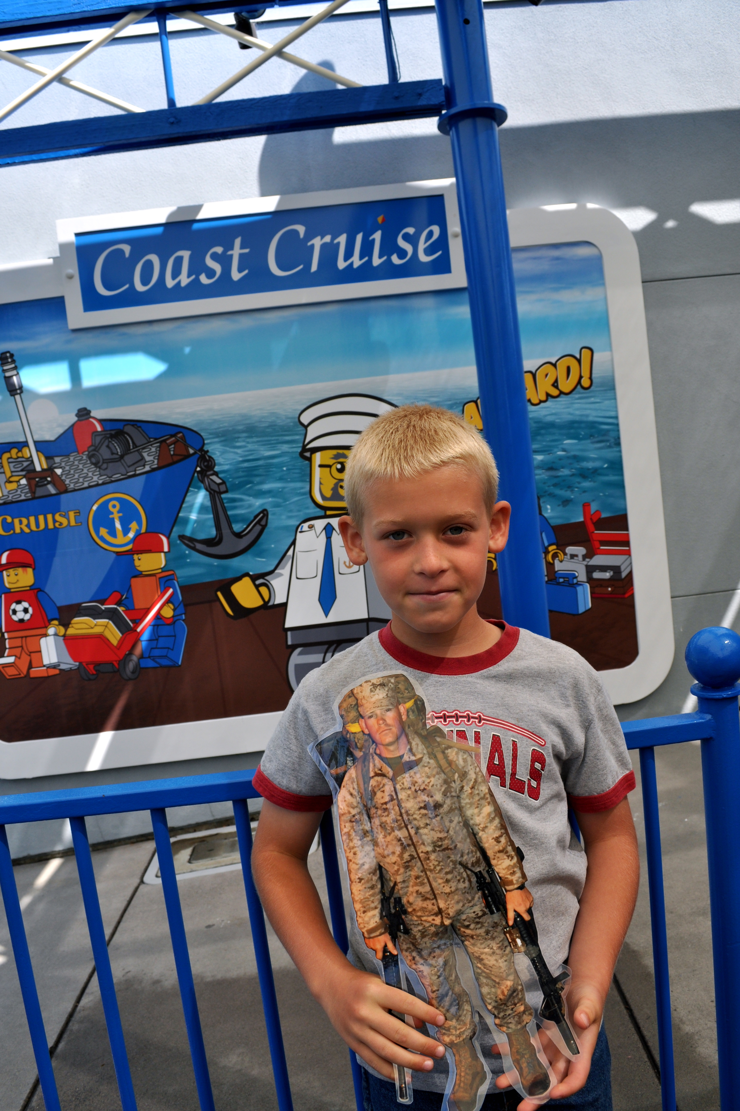
  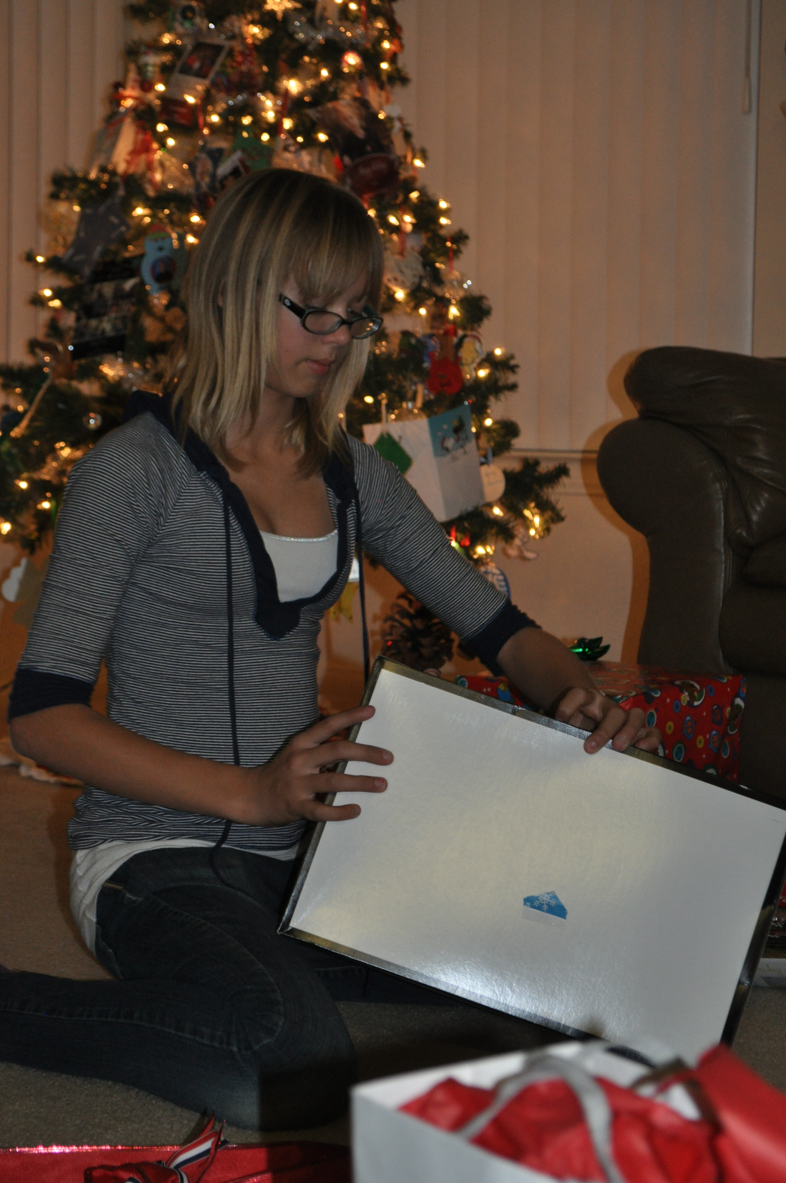
  Mission Family
  
  
  PHOTOGRAPHER
  ~ MARIA BARGER ~
  Please see our Photo Gallery at Costcophotocenter.com
  e-mail: marbellalc@yahoo.com password: 4marbella. If you have any photos from any of the events, we can still upload onto the website. Please let us know.
  Anyone desiring a copy of a photo, please contact me with a description of the photo and I will gladly E-Mail you a copy. Maria Barger: parteebar@cox.net
  Past 2010/2012 Newsletters
  Thank you for visiting our web site!

