Ladies Golf Club of Marbella
FROM THE RED TEES

  HOME
  2011 LCOM BOARD
  FROM THE RED TEES
  PHOTO GALLERY
  2011 CALENDAR
  ABOUT LCOM
  FORMS
  PAST NEWSLETTERS
  Chairman, Jill Blurton-Jones
  
  April 2011
  Once the clocks had changed, I assumed that our weather would get better…. …that was not to be! We experienced wind, rain, sunny and cloudy skies and cold conditions. Despite the weather we played in a full schedule of tournaments :
  Ladies Guest Day, President’s Cup, Couples Bit O’Blarney, followed by our very popular Member/Member Ecletic. What’s amazing is that despite the elements there were no rain delays and all our tournaments were successfully completed.
  We experienced a few “bumps in the road”, but the important thing is that all the tournaments were well attended with good camaraderie, and a great time was had by all! Running the tournaments is truly an all encompassing task for Tina Russell, her co-chairs Joey Knudson & Judy Davis and all the other ladies involved, including Yolanda Talbot(Rules)and Rona Kipper (Handicap). No one realizes how much time is spent planning and executing these events. There is so much work involved it is “mind boggling”. Despite the criticism and the lousy pay everyone involved puts on a spectacular show!!!! Thank you to all the ladies running these tournaments….. “hats off to you!”
  Nick tells me that recently I have been talking in my sleep about Marbella board meetings, luckily I don’t have my gavel at hand! So please show some respect and understanding for our LCOM Board who give so much of their time, deserve to be heard in meetings, and who have unwaveringly volunteered their support and are prepared to “step up to the plate”.
  Some of our ladies from Spring Team enjoyed a great getaway organized and led by Georgianna Hales & Suzi Olsen our team captains, playing at Pechanga & Cross Creek, where we had an adventurous time playing very difficult courses. We also enjoyed fabulous food and wine and partied hard and some of our ladies recouped the value of their lost golf balls in the casino later that night!
  The fairways at Marbella are looking lush and green and playing better than before all the rainy weather. Some of our tee boxes have been leveled and even though the greens have been aerated the condition of our golf course is great and we need to give special thanks to Vince and his superb maintenance crew. I would also like to thank Robin Shelton and all the pro shop staff for their help and support.
  This month we will not be having a General Meeting, so our next meeting will be on 5th May. Spring team starts on the 14th April “Go team go”!!!!! followed by Couples Member/Guest “Cinco de Mayo” scheduled for 30th April, the reason it is a week early is because of the preparation for the club’s Mother’s Day on 8thMay. If you haven’t been to Mother’s Day brunch at Marbella you are missing out on a spectacular event, and I would urge you to make your booking asap.
  We also have arranged a reciprocal “Home & Home”at Marbella with Palos Verdes on the 19th May run by Charlene & Nancy, we go to Palos Verdes which is a fun course to play on the 16th June when aerification of our fairways start.
  I would like to wish you all a “Happy Mother’s Day”.
  Please enjoy this special day.
  Jill Blurton-Jones
  PK Jenican
  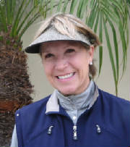
  MEMBERSHIP
  ~PK Jenican~
  Don’t forget to pick up your 2011 Ladies LCOM Roster book if you have yet to do so. Remaining books for Ladies that have Lockers were placed in their Lockers.
  April Birthdays
  Katherine Szem 4/5
  Nancy Cleermans 4/10
  Shelly Lawrence 4/10
  Georgianna Hales 4/15
  Carol Warlick 4/16
  PK Jenican 4/17
  Marcia Smith 4/18
  Barbara Gray 4/19
  Lori Hathaway 4/25
  Bev Letter 4/28
  Zeniya Kobtseva 4/30
  WSCGA Newsletter TEE Talk has gone Digital and now available on the website. Wscga@womensgolf.org
  WSCGA 2011 Events
  April 4-5 DIV II Fortmiller Net Championship Escens Golf Course
  Individual Stoke Play
  April16 Womens Golf Council Tournament Golf Club at La Quinta
  May 2-3 DIV I Desert Event Desert Falls CC
  Better Ball of Partner Desert Island CC
  Ironwood CC
  June 13 DIV I-II Open Play Day Glen Annie Golf Club
  Format TBD
  June 25 Women’s Council Tournament Arrowood Golf Course
  Format TBD
  July 18-20 California Women’s Championship Tamecula Creek Inn
  Individual Stroke Play
  ~ GENERAL MEETING
  MARCH 24, 2011
  MEMBER/MEMBER WINNERS
  Low Gross and Net Over the Field
  Miki Hayama, Maria Barger, Linda Travis & Susan Taylor
  
  Madonna Flight
  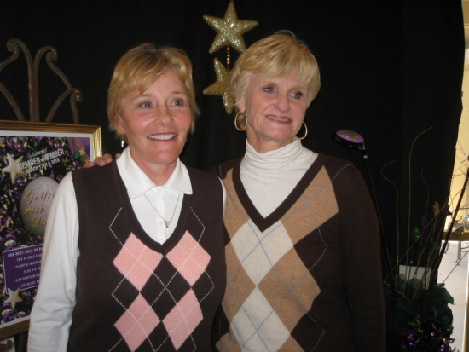
  1st place Gross, Nacy Tall, Sue Pebley
  1st place Net, Jean Kelly, Nancy Cleeremans
  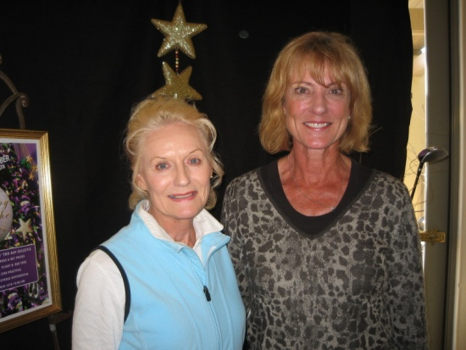
  2nd Gross, Sea Prattes and Ginny Vincent | 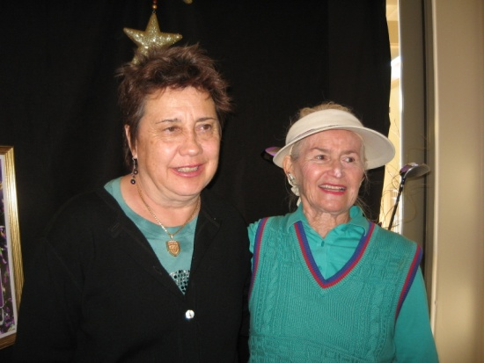
  2nd Net, Shana Martensen and Cheryl Marquis
  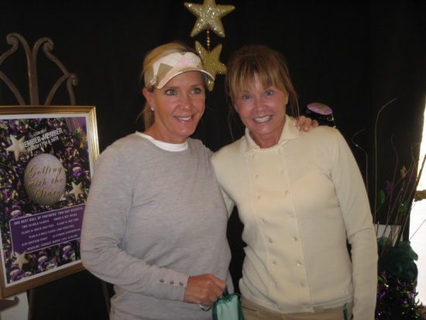
  3rd Place Gross, Carol Gabos and Dani Ratkelis
  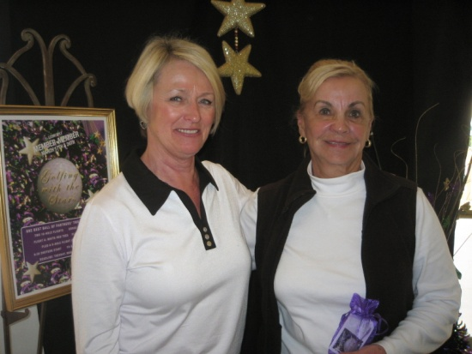
  3rd Place Net, Jill Blurton-Jones & Karen Jordan
  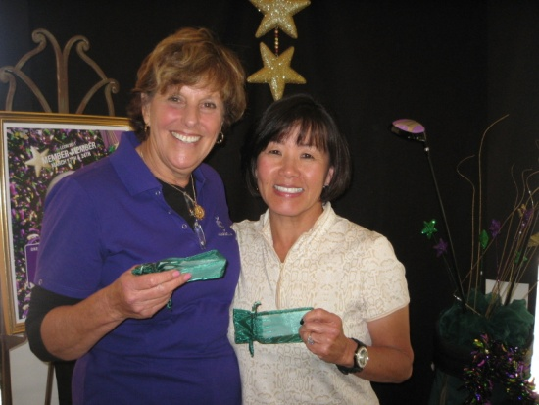
  LADY GAGA FLIGHT
  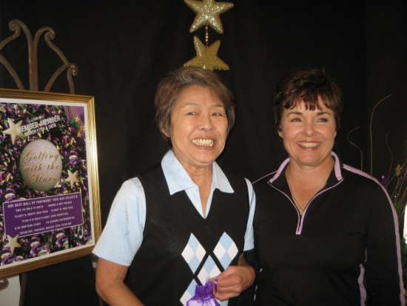
  1st Place Gross, Dorothy Matsuba& Patty Stringer
  1st Place Net, Katherine Szem & Charlene Salmacia
  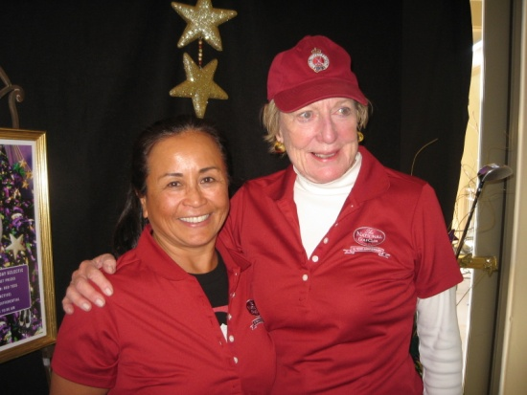
  2nd Place Gross, Maxene Weinberg & Marcia Smith
  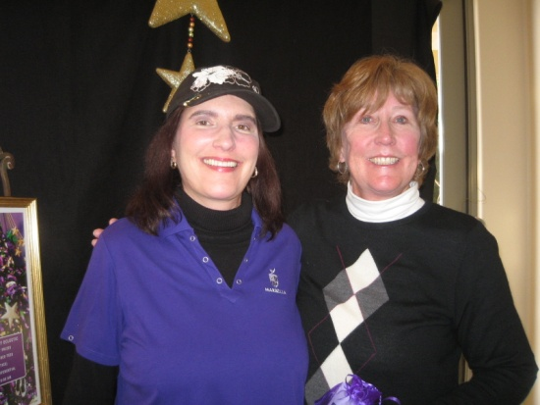
  2nd Place Net, Ute McGlothlin & Jane Demeter
  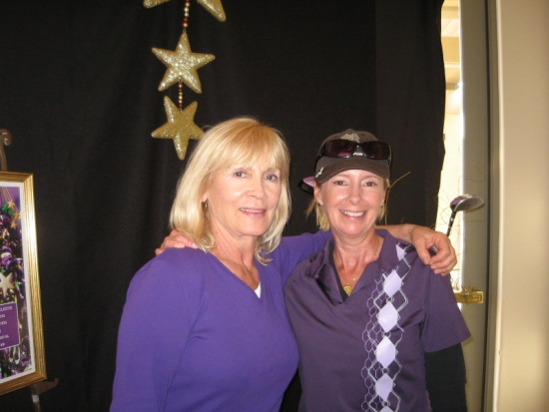
  3rd Place Gross. Sally Orgera & Kay Wood
  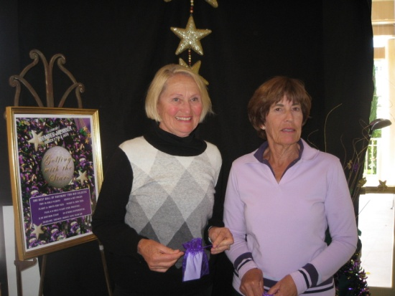
  3rd Place Net, Rona Kipper & Sherri Romito
  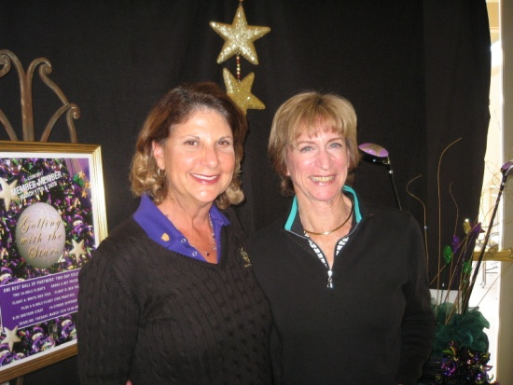
  Closest to the Flag
  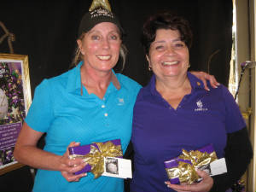
  Bev Stinson #11, Elena Miller #4
  Closest to the Flag
  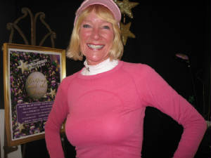
  Carol Pugmire #11, Jeri Rimel #4 Camera shy
  BEYONCE 9 HOLE FLIGHT
  Camera shy:
  1st place Gross: Elizabeth Thiergartner & Laura Ristoff
  2nd Place Net: Tammy Curtis & Julie Roth
  Golfing with the Stars
  2011 Member-Member
  ~Tina Russell~
  This season’s Member-Member, “Golfing with the Stars,” was a most exciting event culminating in the grand finale on March 24th with the winners announced by host Ryan Robin Seacrest. The surprise appearance of the celebrity panel of Paula Abdul, Carrie Ann Inaba and Jennifer Lopez added greatly to the festivity of the awards presentation. It all would not have been possible if not for Co-Chairs Judy Davis and Joey Knudson who used their talent and ability to swing together to coordinate this extravaganza. Their stage crew, Mary Kay Minner, Betsy Woodhouse, and Barbara Behrens, provided superb support and Yolanda Talbot helped tremendously through the tough times. “The show must go on” has a whole new meaning to those working behind the scenes. We would like to congratulate everyone for their performance, sportsmanship, and participation in “Golfing with the Stars” at Marbella!
  2011 MEMBER-MEMBER
  DANCING WITH THE STARS
  * REPRESENTS CARD-OFF
  OVER THE FIELD GROSS |  | Susan Taylor & Linda Travis |  |  |  | 71
  OVER THE FIELD NET |  | Miki Hayama & Maria Barger |  |  |  | 56
  MADONNA (A) FLIGHT
   | 1st Place Gross | Sue Pebley & Nancy Tall |  |  |  | 73
   | 1st Place Net | Jean Kelly & Nancy Cleeremans |  |  |  | 57*
   | 2nd Place Gross | Ginny Vincent & Sea Prattes |  |  |  | 76*
   | 2nd Place Net | Shana Martensen & Cheryl Marquis |  |  |  | 57
   | 3rd Place Gross | Dani Ratkelis & Carol Gabos |  |  |  | 77*
   | 3rd Place Net | Jill Blurton-Jones & Karen Jordan |  |  |  | 58
  LADY GAGA (B) FLIGHT
   | 1st Place Gross | Patti Stringer & Dorothy Matsuba |  |  |  | 80
   | 1st Place Net | Katherine Szem & Charlene Salmacia |  |  |  | 57
   | 2nd Place Gross | Marcia Smith & Maxene Weinberg |  |  |  | 84*
   | 2nd Place Net | Ute McGlothlin & Jane Demeter |  |  |  | 58
   | 3rd Place Gross | Sally Orgera & Kay Wood |  |  |  | 84
   | 3rd Place Net | Rona Kipper & Sherri Romito |  |  |  | 60
  BEYONCE’ (C) 9 HOLE FLIGHT
   | 1st Place Gross | Elizabeth Thiergartner & Laura Ristoff |  |  |  | 45
   | 1st Place Net | Tammy Curtis & Julie Roth |  |  |  | 28
  CLOSEST TO THE FLAG
  #4 | MADONNA FLIGHT | 3/17 |  | Jeri Rimel |  | 6'
  #11 | LADY GAGA FLIGHT | 3/17 |  | Carol Pugmire |  | 10' 2"
  #11 | MADONNA FLIGHT | 3/24 |  | Bev Stinson |  | 1' ll"
  #4 | LADY GAGA FLIGHT | 3/24 |  | Elena Miller |  | 12' 2"
  
  MAJOR TOURNAMENTS
  ~ Charlene Salmacia ~
  Planning is well underway for our Home and Home Events with Palos Verdes Golf Club, May 19 at Marbella and June 16 at PV.
  And yes the suggested bus has been secured for our trek to PV.
  Sign up for one or both days on Fore Tees, under Events. Information is now posted in the Ladies Locker Room!
  A sheet will be posted with info and sign up for the bus. Cost will be approximately $35-$40 per person, depending on number
  of people on the bus.
  ALSO---Save the date June 30--our next Ladies Guest Day at Marbella!
  
  ~COUPLES’ GOLF EVENTS~
  Sally Orgera & Carolyn McGuire
  Our annual Member/Guest is coming soon!
  Invite another couple to be your guests for this celebration
  Cinco de Mayo will be the theme along with Mexican treats and food
  Save the date – Saturday, April 30th with a shotgun start at l:00 p.m.
  The cost is $100/couple (+ cart fees) and includes golf, treats and snacks,
  wine service with dinner and live music and dancing.
  The golf is sure to be a FUN FORMAT with contests on the course
  Awards will be given for Gross and Net
  Sign up on ForeTees for this festive tournament!!!!
  Mark your calendar for Saturday, April 30th for our annual
  Member/Guest Tournament or Cinco de Mayo. Watch for more information to follow soon.
  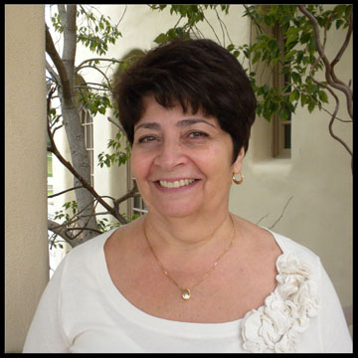
  Play Days
  ~Elena Miller~
  Ladies, Happy Spring! Many thanks to our March hostesses Sherri Romito, Judy Davis and Carol Pugmire. Our April Hostesses are Barbara Klotz, Helen Helbing and Joey Knudson. We are grateful for all their hard work.
  Please remember to put your full name, tees played from and WSCGA # on your game cards. Don’t forget to attest it. Just a reminder: If your game card is not filled out completely and you do not fill out the game sheet, you are not eligible for scrip. Also, the handicap entered on the scoring sheets is from the red tees. If you play other tees, IT IS YOUR RESPONSIBILITY to correct the score sheet. We are not doing this and it makes it very difficult and time consuming to flight by tees for prizes.
  We finally have hostesses for July thanks to Linda Fryling’s tenacity. We could still use another hostess for June and August of this year. I will put a signup sheet next to the computer in the locker room.
  Thank you and let’s have fun out there.
  Saturday March 5, 2011 - “Most Net Pars” –
  1st Place: Karen Jordan, Carole Gabos 9
  Low Gross: Karen Jordan 82
  Low Net: Karen Jordan 71
  Thursday March 10, 2011 - “Hate “em”
  Red/White Flight (7 players)
  1st Place: Susi Olsen 61
  2nd Place: Bev Letter 66
  Red Flight (22 players)
  1st Place: June Kim, Charlene Salmacia 53
  3rd Place: Tina Russell 54
  4th Place: Ginny Vincent 55
  5th Place: Jean Kelly 56
  6th Place: Shelly Lawrence 58
  7th Place: Jane Demeter, Dorothy Matsuba, 59
  Miki Hayama
  Low Gross: June Kim 82
  Low Net: June Kim,Charlene Salmacia 66
  Saturday March 12, 2011 - “Front Nine” – 50% Handicap
  1st Place: Carole Gabos 38
  Low Gross: Sue Pebley 87
  Low Net: Jill Blurton-Jones 77
  Saturday March 19, 2011 - “Back Nine” – 50% Handicap
  1st Place: Carole Gabos 36
  Low Gross: Carole Gabos 85
  Low Net: Carole Gabos 71
  Saturday March 26, 2011 - “Criss Cross” –50% Handicap
  1st Place: June Kim 31
  Low Gross: None
  Low Net: None
  Thursday March 31, 2011 - “Select 9s”
  Red/White Flight (7 players)
  1st Place: Susan Taylor 28
  2nd Place: Jean Kelly 28.5
  Red Flight (15 players)
  1st Place: Ginny Vincent 25.5
  2nd Place: Barbara Behrens, Maria Barger 27.5
  4th Place: Sally Orgera, Joey Knudson, 28
  Helen Helbing
  Low Gross: Susan Taylor 84
  Low Net: Yolanda Talbot, Marcia Smith 70
  Nine Holers
  
  ~Lori Bickel~
  Niners took a road trip to Marriott Shadow Ridge, Palm Desert and golfed the Tacquitz Resort course. At the LCOM Member/Member special Niners Match, Tammy Curtis & Julie Roth won lowest net , Elizabeth Thiergartner & Laura Ristoff won lowest gross. Lori Powers & Lori Bickel played in the tournament, but were just happy to be included in the lovely tee prize the committee picked out.
  At the couples Bit O’ Blarney, Julie & Marty Roth and their partners Linda & Doug Cunningham came in 2nd place net. Congrats! Tammy & Dan Curtis and Lori & Jim Bickel also participated, but let’s just say… they had fun dancing afterward, but no wins. All in all, great fun at the club with the rest of the LCOM members! Last, but not least, a big “Welcome Back” to Xeniya Kobtseva/Baum.
  
  ~Handicap~
  Rona Kipper
  Ladies' please remember to post at all courses
  Handicap--Rona Kipper
  MOST IMPROVED FOR APRIL
  to be announced
  YOLANDA TALBOT
  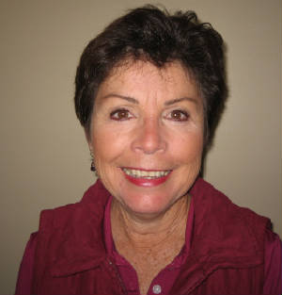
  RULES CHAIRMAN
  ~ RULES ~
  YOLANDA TALBOT
  Rule 13-2 Improving Lie, Area of Intended Stance or Swing, or Line of Play
  With our newly punched and sanded greens, I thought I would briefly talk about the Line of Play. When you are off the green but decide to putt to the hole, it is not permissible to remove sand or loose soil which is off the putting green but on the line of play. Once you’re on the green, you can remove loose impediments such as leaves, sand, etc. However, you cannot remove dew, frost or water.
  I will have a short questionnaire to test your knowledge of the rules at the next General Meeting (just for fun!). Also, if there are any rules questions you would like me to address in the newsletter, feel free to email them to me.
  
  PHOTOGRAPHER
  ~ MARIA BARGER ~
  Please see our Photo Gallery at Costcophotocenter.com
  e-mail: marbellalc@yahoo.com password: marbella. If you have any photos from any of the events, we can still upload onto the website. Please let us know.
  Anyone desiring a copy of a photo, please contact me with a description of the photo and I will gladly E-Mail you a copy. Maria Barger: parteebar@cox.net
  Past 2009/2010 Newsletters
  Thank you for visiting our web site!

